

|  |
| --- |
| **TENDER DOSSIER** |
| **EUROPEAID/139244/DH/SUP/GE** |

|  |
| --- |
| **PART A** |

|  |
| --- |
| **INSTRUCTIONS TO TENDERERS** |

# A. INSTRUCTIONS TO TENDERERS

PUBLICATION REF.: EUROPEAID/139244/DH/SUP/GE

By submitting a tender, tenderers fully and unreservedly accept the special and general conditions governing the contract as the sole basis of this tendering procedure, whatever their own conditions of sale may be, which they hereby waive. Tenderers are expected to examine carefully and comply with all instructions, forms, contract provisions and specifications contained in this tender dossier. Failure to submit a tender containing all the required information and documentation within the deadline specified will lead to the rejection of the tender. No account can be taken of any remarks in the tender relating to the tender dossier; remarks may result in the immediate rejection of the tender without further evaluation.

These Instructions set out the rules for the submission, selection and implementation of contracts financed under this call for tenders, in conformity with the Practical Guide (available on the Internet at: <http://ec.europa.eu/europeaid/prag/document.do>).

# 

# Supplies to be provided

## The subject of the contract is the supply, delivery, installation and commissioning at different EUMM operated premises of the equipment outlined in the table below and further described in Part B of this tender dossier.

|  |  |  |
| --- | --- | --- |
| **Item Nº** | **Item description** | **Quantity** |
| 1 | Diesel generator set (minimum 80 kVA) | 1 |
| 2 | Diesel generator set (between 450 kVA and 510 kVA) | 1 |
| 3 | Stabilizer (minimum 150 kVA) | 3 |
| 4 | Stabilizer (minimum 400 kVA) | 1 |
| 5 | Series of 2 training sessions | 2 |

## 1.2 The supplies must comply fully with the technical specifications set out in the tender dossier (technical annex) and conform in all respects with the drawings, quantities, models, samples, measurements and other instructions.

## 1.3 Delivery Arrangements are mentioned in annex II&III of this tender dossier.

## 1.4 Tenderers are not authorised to tender for a variant solution in addition to the present tender.

# 

# Timetable

|  |  |  |
| --- | --- | --- |
|  | **DATE** | **TIME\*** |
| **Clarification meeting / site visit (if any)** | n/a | n/a |
| **Deadline for requesting clarifications from the Contracting Authority** | 29 September 2017 | 24:00 hrs  local time of Georgia |
| **Last date on which clarifications are issued by the Contracting Authority** | 9 October 2017 | 24:00 hrs  local time of Georgia |
| **Deadline for submission of tenders** | **20 October 2017** | **15:00 hrs**  **local Georgian Time** |
| **Tender opening session** | 20 October 2017 | 15:30 hrs  local Georgian Time |
| **Notification of award to the successful tenderer** | October/November 2017 | - |
| **Signature of the contract** | November 2017 | - |

**\* All times are in the time zone of the country of the Contracting Authority Provisional date**

# Participation

3.1 Tendering is open on equal terms to natural and legal persons (participating either individually or in a grouping – consortium - of tenderers). Tendering is also open to international organisations.

## 3.2 Natural or legal persons are not entitled to participate in this tender procedure or be awarded a contract if they are in any of the situations mentioned in Sections 2.3.3.1 or 2.3.3.2 of the Practical Guide. Should they do so, their tender will be considered unsuitable or irregular respectively. In the cases listed in Section 2.3.3.1 of the **Practical Guide** tenderers may also be excluded from EU financed procedures and be subject to financial penalties representing 2 % to 10 % of the total value of the contract in accordance with the conditions set in Section 2.3.4 of the **Practical Guide**. This information may be published on the Commission website in accordance with the conditions set in Section 2.3.4 of the Practical Guide. Tenderers must provide declarations that they are not in any of these exclusion situations. The declarations must cover all the members of a joint venture/consortium. Tenderers who make false declarations may also incur financial penalties and exclusion in accordance with section 2.3.4 of the Practical Guide. Their tender will be considered irregular.

## The exclusion situations referred to above also apply to all members of a joint venture/consortium, all subcontractors and all suppliers to tenderers, as well as to all entities upon whose capacity the tenderer relies for the selection criteria. When requested by the Contracting Authority, tenderers/contractors must submit declarations from the intended subcontractors that they are not in any of the exclusion situations. In cases of doubt over declarations, the Contracting Authority will request documentary evidence that subcontractors are not in a situation that excludes them.

## 3.6 Where tenders include subcontracting, it is recommended that the contractual arrangements between tenderers and their subcontractors include mediation, according to national and international practices, as a method of dispute resolution.

# Origin

## No restrictions whatsoever shall apply to the origins of the supplies.

# Type of contract

## Fixed unit-price (supply contract).

# Currency

## Tenders must be presented in Euro.[1]

# Lots

This tender procedure is not divided into lots.

# Period of validity

## 8.1 Tenderers will be bound by their tenders for a period of 90 days from the deadline for the submission of tenders.

## 8.2 In exceptional cases and prior to the expiry of the original tender validity period, the Contracting Authority may ask tenderers in writing to extend this period by 40 days. Such requests and the responses to them must be made in writing. Tenderers that agree to do so will not be permitted to modify their tenders and they are bound to extend the validity of their tender guarantees for the revised period of validity of the tender. If they refuse, without forfeiture of their tender guarantees, their participation in the tender procedure will be terminated. In case the contracting authority is required to obtain the recommendation of the panel referred to in section 2.3.3.1 of the Practical Guide, the contracting authority may, before the validity period expires, request an extension of the validity of the tenders up to the adoption of that recommendation.

8.3 The successful tenderer will be bound by its tender for a further period of 60 days. The further period is added to the validity period of the tender irrespective of the date of notification.

# Language of tenders

## 9.1 The tenders, all correspondence and documents related to the tender exchanged by the tenderer and the Contracting Authority must be written in the language of the procedure, which is English.

## Supporting documents and printed literature furnished by the tenderer may be in another language, provided they are accompanied by a translation into English. Only documents which are submitted in English will be taken into account during the tender evaluation process. For the purposes of interpretation of the tender, the English version of any document submitted in a different language is to be deemed the correct authoritative version.

# Submission of tenders

## 10.1 The Contracting Authority must receive the tenders before the deadline specified in 10.3. They must include all the documents specified in point 11 of these Instructions and be sent to the following address:

**European Union Monitoring Mission in Georgia (EUMM)**

**Procurement Section**

**49 Krtsanisi Street**

**0114 Tbilisi**

**Georgia**

If the tenders are hand delivered they should be delivered to the following address:

**European Union Monitoring Mission in Georgia (EUMM)**

**Procurement Section**

**49 Krtsanisi Street**

**0114 Tbilisi  
Georgia**

Tenders must comply with the following conditions:

## 10.2 All tenders must be submitted in one original, marked ‘original’, and two copies signed in the same way as the original and marked ‘copy’.

## 10.3 All tenders must be received at the EUMM headquarters (49 Krtsanisi Street, 0114 Tbilisi, Georgia) before **20 October 2017, at** **15hrs00 Georgian Standard Time GET (i.e. Greenwich Main Time GMT +4)**, by registered letter with acknowledgement of receipt or hand-delivered against receipt signed by its representative

## 10.4 All tenders, including annexes and all supporting documents, must be submitted in a sealed envelope bearing only:

a) the EUMM address specified in 10.1 above;

b) the reference number of this tender procedure EUROPEAID/139244/DH/SUP/GE;

c) the words “Not to be opened before the tender opening session” and "არ უნდა გაიხსნას ტენდერის ჩატარების მომენტამდე";

d) the name of the tenderer.

The technical and financial offers must be placed together in a sealed envelope. The envelope should then be placed in another single sealed envelope/package, unless their volume requires a separate submission.

# Content of tenders

Failure to fulfil the below requirements will constitute an irregularity and may result in rejection of the tender. All tenders submitted must comply with the requirements in the tender dossier and comprise:

**Part 1: Technical offer:**

## A detailed description of the supplies tendered in conformity with the technical specifications, including any documentation required.

The technical offer should be presented as per template (Annex II+III, Contractor’s technical offer) adding separate sheets for details if necessary.

The following documentation must also be supplied along with the technical offer:

**(1) Generator set photographs of all sides.**

**(2) Generator set technical data, design and performance, specifications (tabulated data that identifies make, model and country of origin as an attachment) for the following:**

a) Engine (including its relevant components).

b) Alternator (including its relevant components).

c) Control panel (including its relevant components).

d) Auxiliary components:

(i) Electrical charger.

(ii) Generator set circuit breaker, etc.

(iii) Starter components.

(iv) Injection pump.

(v) Exhaust system.

**(3) Drawings**

General dimensions drawings showing overall generator set measurements, mounting location, and interconnects points for load leads, fuel, exhaust, cooling and drain lines.

**(4) All wiring and schematic drawings showing detailed circuits.**

In addition to the above, any bidder must be able to prove, via any medium (website, catalogue, copied certificate, etc.), that the manufacturer/s of the generator equipment being offered:

* Is/are in possession of an ISO 9001 certification;
* Has/have a representative service company within Georgia that holds an official manufacturer’s authorization form or certificate or similar.

**Part 2: Financial offer:**

A financial offer calculated on a DDP[2] basis for the supplies tendered.

This financial offer should be presented as per template (Annex IV*, Budget breakdown), adding separate sheets for details if necessary.

An electronic version of the financial offer.

**Part 3: Documentation:**

To be supplied using the templates attached[3]:

* The ‘Tender Form for a Supply Contract’, together with its Annex 1 'Declaration of honour on exclusion criteria and selection criteria', both duly completed, which includes the tenderer’s declaration (point 7), (from each member if a consortium);
* The details of the bank account into which payments should be made (financial identification form). Tenderers that have already signed another contract with the European Commission or the EUMM, may provide a copy of the financial identification form furnished on that occasion, if no change has occurred in the meantime;
* The legal entity file and the supporting documents (Tenderers that have already signed another contract with the European Commission or the EUMM may provide a copy of the legal entity sheet furnished on that occasion, if no change in legal status has occurred in the meantime).

To be supplied in free-text format:

* A description of the warranty conditions, which must be in accordance with the conditions laid down in Article 32 of the General Conditions.
* Duly authorised signature: an official document (statutes, power of attorney, notary statement, etc.) proving that the person who signs on behalf of the company, joint venture or consortium is duly authorised to do so.

Remarks:

Tenderers are requested to follow this order of presentation.

Annex* refers to templates attached to the tender dossier. These templates are also available on: <http://ec.europa.eu/europeaid/prag/annexes.do?group=C>

# Taxes and other charges

Exemption of taxes:

The European Union and Georgia have agreed in as per Agreement between the European Union and Georgia on The Status of The European Union Monitoring Mission in Georgia (SOMA) 3 November 2008: **“**EUMM Georgia, shall be exempt from all national, regional and communal dues, taxes and charges of a similar nature in respect of purchased and imported goods, services provided and facilities used by it for the purposes of the Mission”.

# Additional information before the deadline for submission of tenders

The tender dossier should be so clear that tenderers do not need to request additional information during the procedure. If the Contracting Authority, on its own initiative or in response to a request from a prospective tenderer, provides additional information on the tender dossier, it must send such information in writing to all other prospective tenderers at the same time.

Tenderers may submit questions in writing to the following email address on or before the 29 September, 2017, specifying the reference number and the contract title: [tenders@eumm.eu](mailto:tenders@eumm.eu)

The Contracting Authority has no obligation to provide clarifications after this date.

Any clarification of the tender dossier will be communicated simultaneously in writing to all prospective tenderers by the 9 October, 2017 at the latest.

Any prospective tenderers seeking to arrange individual meetings with either the Contracting Authority and/or the European Commission during the tender period may be excluded from the tender procedure.

# Clarification meeting / site visit

14.1 No clarification meeting / site visit planned. Visits by individual prospective tenderers during the tender period cannot be organised.

# Alteration or withdrawal of tenders

## 15.1 Tenderers may alter or withdraw their tenders by written notification prior to the deadline for submission of tenders referred to in Article 10.3. No tender may be altered after this deadline. Withdrawals must be unconditional and will end all participation in the tender procedure.

## 15.2 Any such notification of alteration or withdrawal must be prepared and submitted in accordance with Article 10. The outer envelope must be marked ‘Alteration’ or ‘Withdrawal’ as appropriate.

## 15.3 No tender may be withdrawn in the interval between the deadline for submission of tenders referred to in Article 10.3 and the expiry of the tender validity period.

# Costs of preparing tenders

No costs incurred by the tenderer in preparing and submitting the tender are reimbursable. All such costs will be borne by the tenderer.

# Ownership of tenders

The Contracting Authority retains ownership of all tenders received under this tender procedure. Consequently, tenderers have no right to have their tenders returned to them.

# Joint venture or consortium

## 18.1 If a tenderer is a joint venture or consortium of two or more persons, the tender must be a single one with the object of securing a single contract, each person must sign the tender and will be jointly and severally liable for the tender and any contract. Those persons must designate one of their members to act as leader with authority to bind the joint venture or consortium. The composition of the joint venture or consortium must not be altered without the prior written consent of the Contracting Authority.

## 18.2 The tender may be signed by the representative of the joint venture or consortium only if it has been expressly so authorised in writing by the members of the joint venture or consortium, and the authorising contract, notarial act or deed must be submitted to the Contracting Authority in accordance with point 11 of these Instructions to Tenderers. All signatures to the authorising instrument must be certified in accordance with the national laws and regulations of each party comprising the joint venture or consortium together with the powers of attorney establishing, in writing, that the signatories to the tender are empowered to enter into commitments on behalf of the members of the joint venture or consortium.

# Opening of tenders

## 19.1 The opening and examination of tenders is for the purpose of checking whether the tenders are complete, whether the required documents have been properly included and whether the tenders are generally in order.

## 19.2 The tenders will be opened in public session on **20 October 2017, 15:30 hrs Local time of Georgia** at the **EUMM Headquarters (49 Krtsanisi Street – 0114 Tbilisi – Georgia)** by the committee appointed for the purpose. The committee will draw up minutes of the meeting, which will be available on request. Tenderers’ representatives that intend to participate to the public opening are kindly requested to inform the contracting authority by sending an e-mail at the following address [tenders@eumm.eu](mailto:tenders@eumm.eu)at least 24 hours in advance**.**

## 19.3 At the tender opening, the tenderers’ names, the tender prices, any discount offered, written notifications of alteration and withdrawal, the presence of the requisite tender guarantee (if required) and such other information as the Contracting Authority may consider appropriate may be announced.

## 19.4 After the public opening of the tenders, no information relating to the examination, clarification, evaluation and comparison of tenders, or recommendations concerning the award of the contract can be disclosed until after the contract has been awarded.

## 19.5 Any attempt by tenderers to influence the evaluation committee in the process of examination, clarification, evaluation and comparison of tenders, to obtain information on how the procedure is progressing or to influence the Contracting Authority in its decision concerning the award of the contract will result in the immediate rejection of their tenders.

## 19.6 All tenders received after the deadline for submission specified in the contract notice or these instructions will be kept by the Contracting Authority. The associated guarantees will be returned to the tenderers. No liability can be accepted for late delivery of tenders. Late tenders will be rejected and will not be evaluated.

# Evaluation of tenders

## 20.1 Examination of the administrative conformity of tenders

The aim at this stage is to check that tenders comply with the essential requirements of the tender dossier. A tender is deemed to comply if it satisfies all the conditions, procedures and specifications in the tender dossier without substantially departing from or attaching restrictions to them.

Substantial departures or restrictions are those which affect the scope, quality or execution of the contract, differ widely from the terms of the tender dossier, limit the rights of the Contracting Authority or the tenderer’s obligations under the contract or distort competition for tenderers whose tenders do comply. Decisions to the effect that a tender is not administratively compliant must be duly justified in the evaluation minutes.

If a tender does not comply with the tender dossier, it will be rejected immediately and may not subsequently be made to comply by correcting it or withdrawing the departure or restriction.

## 20.2 Technical evaluation

After analysing the tenders deemed to comply in administrative terms, the evaluation committee will rule on the technical admissibility of each tender, classifying it as technically compliant or non-compliant.

## The minimum qualifications required (see selection criteria in Contract notice point 16) are to be evaluated at the start of this stage.

Where contracts include after-sales service and/or training, the technical quality of such services will also be evaluated by using yes/no criteria as specified in the tender dossier.

## 20.3 In the interests of transparency and equal treatment and to facilitate the examination and evaluation of tenders, the evaluation committee may ask each tenderer individually for clarification of its tender including breakdowns of prices, within a reasonable time limit to be fixed by the evaluation committee. The request for clarification and the response must be in writing, but no change in the price or substance of the tender may be sought, offered or permitted except as required to confirm the correction of arithmetical errors discovered during the evaluation of tenders pursuant to Article 20.4. Any such request for clarification must not distort competition. Decisions to the effect that a tender is not technically compliant must be duly justified in the evaluation minutes.

## 20.4 Financial evaluation

a) Tenders found to be technically compliant will be checked for any arithmetical errors in computation and summation. Errors will be corrected by the evaluation committee as follows:

- where there is a discrepancy between amounts in figures and in words, the amount in words will be the amount taken into account;

- except for lump-sum contracts, where there is a discrepancy between a unit price and the total amount derived from the multiplication of the unit price and the quantity, the unit price as quoted will be the price taken into account.

b) Amounts corrected in this way will be binding on the tenderer. If the tenderer does not accept them, its tender will be rejected.

c) Unless specified otherwise, the purpose of the financial evaluation process is to identify the tenderer offering the lowest price. Where specified in the technical specifications, the evaluation of tenders may take into account not only the acquisition costs but, to the extent relevant, costs borne over the life cycle of the supplies (such as for instance maintenance costs and operating costs), in line with the technical specifications. In such case, the Contracting Authority will examine in detail all the information supplied by the tenderers and will formulate its judgment on the basis of the lowest total cost, including additional costs.

## 20.5 Variant solutions

Variant solutions will not be taken into consideration.

## 20.6 Award criteria

The sole award criterion will be the price. The contract will be awarded to the lowest compliant tender.

# Signature of the contract and performance guarantee

21.1 The successful tenderer will be informed in writing that its tender has been accepted (notification of award). Before the Contracting Authority signs the contract with the successful tenderer, the successful tenderer may be required to provide the **documentary proof** or statements required under the law of the country in which the company (or each of the companies in case of a consortium) is effectively established, to show that it is not in any of the exclusion situations listed in section 2.3.3 of the Practical Guide. This evidence or these documents or statements must carry a date not earlier than one year before the date of submission of the tender. In addition, a statement must be provided that the situations described in these documents have not changed since then.

## 21.2 The successful tenderer may also be required to provide evidence of financial and economic standing and technical and professional capacity according to the selection criteria for this call for tenders specified in the contract notice, point 16. The documentary proofs required are listed in section 2.4.11 of the Practical Guide.

## 21.3 If the successful tenderer fails to provide the documentary proof or statement or the evidence of financial and economic standing and technical and professional capacity within 15 calendar days of receiving a request from the Contracting Authority or if the successful tenderer is found to have provided false information, the award will be considered null and void. In such a case, the Contracting Authority may award the tender to the next lowest tenderer or cancel the tender procedure.

The Contracting Authority may waive the obligation of any candidate or tenderer to submit the documentary evidence referred to above if such evidence has already been submitted for the purposes of another procurement procedure, provided that the issue date of the documents does not exceed one year and that they are still valid. In this case, the candidate or tenderer must declare on his/her honour that the documentary evidence has already been provided in a previous procurement procedure and confirm that his/her situation has not changed.

The Contracting Authority may, at its sole discretion, decide not to require the documentary proof of the selection criteria, but in that case no pre-financing will be granted.

By submitting a tender, each tenderer accepts to receive notification of the outcome of the procedure by electronic means. Such notification shall be deemed to have been received on the date upon which the contracting authority sends it to the electronic address referred to in the offer.

## 21.5 Within 30 days of receipt of the contract signed by the Contracting Authority, the selected tenderer must sign and date the contract and return it, with the performance guarantee (if applicable), to the Contracting Authority. On signing the contract, the successful tenderer will become the Contractor and the contract will enter into force.

## 21.6 If it fails to sign and return the contract and any financial guarantee required within 30 days after receipt of notification, the Contracting Authority may consider the acceptance of the tender to be cancelled without prejudice to the Contracting Authority’s right to seize the guarantee, claim compensation or pursue any other remedy in respect of such failure, and the successful tenderer will have no claim whatsoever on the Contracting Authority.

# Tender guarantee

No tender guarantee is required.

# Ethics clauses

## 23.1 Any attempt by a candidate or tenderer to obtain confidential information, enter into unlawful agreements with competitors or influence the committee or the Contracting Authority during the process of examining, clarifying, evaluating and comparing tenders will lead to the rejection of their candidacy or tender and may result in administrative penalties.

## 23.2 Without the Contracting Authority’s prior written authorisation, a Contractor and its staff or any other company with which the Contractor is associated or linked may not, even on an ancillary or subcontracting basis, supply other services, carry out works or supply equipment for the project. This prohibition also applies to any other projects that could, owing to the nature of the contract, give rise to a conflict of interest on the part of the Contractor.

## 23.3. When submitting a tender, tenderers must declare that they are not affected by a conflict of interest and have no equivalent relation in that respect with other tenderers or parties involved in the project. Should such a situation arise during execution of the contract, the Contractor must immediately inform the Contracting Authority.

## 23.4 Contractors must at all times act impartially and as faithful advisers in accordance with the code of conduct of their profession. They will refrain from making public statements about the project or services without the Contracting Authority’s prior approval. They may not commit the Contracting Authority in any way without its prior written consent.

## 23.5 For the duration of the contracts Contractors and their staff must respect human rights and undertake not to offend the political, cultural and religious mores of the beneficiary state. In particular and in accordance with the legal basic act concerned, tenderers that have been awarded contracts must abide by core labour standards as defined in the relevant International Labour Organisation conventions (such as the Conventions on freedom of association and collective bargaining; Abolition of forced and compulsory labour; Elimination of forced and compulsory labour; Abolition of child labour).

## 23.6 Contractors may accept no payment connected with the contracts other than that provided for therein. Contractors and their staff must not exercise any activity nor receive any advantage inconsistent with their obligations to the Contracting Authority.

## 23.7 Contractors and their staff are obliged to maintain professional secrecy for the entire duration of contracts and after their completion. All reports and documents drawn up or received by Contractors will be confidential.

## 23.8 The contract governs the Contracting Parties’ use of all reports and documents drawn up, received or presented by them during the implementation of the contract.

## 23.9 Contractors must refrain from any relationship likely to compromise their independence or that of their staff. If the Contractor ceases to be independent, the Contracting Authority may, regardless of injury, terminate the contract without further notice and without the Contractor having any claim to compensation.

## 23.10 The Commission reserves the right to suspend or cancel project financing if corrupt practices of any kind are discovered at any stage of the award process and if the Contracting Authority fails to take all appropriate measures to remedy the situation. For the purposes of this provision, ‘corrupt practices’ are the offer of a bribe, gift, gratuity or commission to any person as an inducement or reward for performing or refraining from any act relating to the award of a contract or implementation of a contract already concluded with the Contracting Authority.

## 23.11 All tenders will be rejected or contracts terminated if it emerges that the award or implementation of a contract has given rise to unusual commercial expenses. Such unusual commercial expenses are commissions not mentioned in the main contract or not stemming from a properly concluded contract referring to the main contract, commissions not paid in return for any actual and legitimate service, commissions remitted to a tax haven, commissions paid to a recipient who is not clearly identified or commissions paid to a company which has any appearance of being a front company.

## 23.12 The Contractor undertakes to supply the Commission on request with all supporting documents relating to the conditions of the contract’s execution. The Commission may carry out whatever documentary or on-the-spot checks it deems necessary to find evidence in cases of suspected unusual commercial expenses.

## 23.13 Contractors found to have paid unusual commercial expenses on projects funded by the EU are liable, depending on the seriousness of the facts observed, to have their contracts terminated or to be permanently excluded from receiving EU funds.

## 23.14 The Contracting Authority reserves the right to suspend or cancel the procedure, if the award procedure proves to have been subject to substantial errors, irregularities or fraud. Where such substantial errors, irregularities or fraud are discovered after the award of the Contract, the Contracting Authority may refrain from concluding the Contract.

# Cancellation of the tender procedure

If a tender procedure is cancelled, tenderers will be notified by the Contracting Authority. If the tender procedure is cancelled before the tender opening session the sealed envelopes will be returned, unopened, to the tenderers.

Cancellation may occur, for example, if:

* the tender procedure has been unsuccessful, namely where no suitable, qualitatively or financially acceptable tender has been received or there has been no valid response at all;
* the economic or technical parameters of the project have changed fundamentally;
* exceptional circumstances or *force majeure* render normal implementation of the project impossible;
* all technically acceptable tenders exceed the financial resources available;
* there have been substantial errors, irregularities or frauds in the procedure, in particular where these have prevented fair competition;
* the award is not in compliance with sound financial management, i.e. does not respect the principles of economy, efficiency and effectiveness (e.g. the price proposed by the tenderer to whom the contract is to be awarded is objectively disproportionate with regard to the price of the market.

**In no event will the Contracting Authority be liable for any damages whatsoever including, without limitation, damages for loss of profits, in any way connected with the cancellation of a tender procedure even if the Contracting Authority has been advised of the possibility of damages. The publication of a contract notice does not commit the Contracting Authority to implement the programme or project announced.**

# Appeals

Tenderers believing that they have been harmed by an error or irregularity during the award process may file a complaint. See section 2.4.15 of the Practical Guide at <http://ec.europa.eu/europeaid/prag/document.do>

# Data Protection

If processing your reply to the invitation to tender involves the recording and processing of personal data (such as names, addresses and CVs), such data will be processed[4] solely for the purposes of the performance management and monitoring of the tender and of the contract by the data controller without prejudice to possible transmission to the bodies charge with monitoring or inspection tasks in application of Union law. Details concerning processing of your personal data are available on the privacy statement at

<http://ec.europa.eu/europeaid/prag/annexes.do?chapterTitleCode=A> [5].

# Early Detection and Exclusion System

The tenderers and, if they are legal entities, persons who have powers of representation, decision-making or control over them, are informed that, should they be in one of the situations of early detection or exclusion, their personal details (name, given name if natural person, address, legal form and name and given name of the persons with powers of representation, decision-making or control, if legal person) may be registered in the Early Detection and Exclusion System, and communicated to the persons and entities listed in the above-mentioned Decision, in relation to the award or the execution of a procurement contract.



|  |
| --- |
| **TENDER DOSSIER** |
| **EUROPEAID/139244/DH/SUP/GE** |

|  |
| --- |
| **PART B** |

|  |
| --- |
| **DRAFT CONTRACT &**  **SPECIAL CONDITIONS** |

|  |
| --- |
| **GENERAL CONDITIONS** |

|  |
| --- |
| **TECHNICAL SPECIFICATIONS**  **& TECHNICAL OFFER** |

|  |
| --- |
| **BUDGET BREAKDOWN** |

|  |
| --- |
| **LEGAL ENTITY FORM & FINANCIAL IDENTIFICATION FORM** |

# DRAFT CONTRACT

SUPPLY CONTRACT FOR EUROPEAN

UNION EXTERNAL ACTIONS

No <Contract number>

**financed from the EU General Budget**

The European Union Monitoring Mission in Georgia (EUMM)

49 Krtsanisi Street

0114 Tbilisi

Georgia

("The Contracting Authority"),

of the one part,

and

<Full official name of Contractor>

[<Legal status/title>]

[<Official registration number>]

<Full official address>

[<VAT number>],

(“the Contractor”)

of the other part,

have agreed as follows:

**CFSP/2016/23/EUMM Georgia**

**Contract for the supply, delivery, installation and commissioning of generators and stabilizers at various premises operated by the EUMM Georgia**

**Publication reference: EUROPEAID/139244/DH/SUP/GE**

**Article 1 Subject**

1.1 The subject of the contract shall be the the supply, delivery, installation and commissioning at different EUMM operated premises of the equipment outlined in the table below and further described in Part B of this tender dossier:

|  |  |  |
| --- | --- | --- |
| **Item Nº** | **Item description** | **Quantity** |
| 1 | Diesel generator set (minimum 80 kVA) | 1 |
| 2 | Diesel generator set (between 450 kVA and 510 kVA) | 1 |
| 3 | Stabilizer (minimum 150 kVA) | 3 |
| 4 | Stabilizer (minimum 400 kVA) | 1 |
| 5 | Series of 2 training sessions | 2 |

1.2 The Contractor shall comply strictly with the terms of the Special Conditions and the Technical Annex.

The Contractor bears the ultimate responsibility for loss or damage to the goods covered by this contract during transport or during the disassembling, loading, unloading, installation and commissioning processes. The inspection and acceptance of such goods – which shall take place within 15 calendar days from the dates of their complete installation and commissioning at the places referred to in the tables above – will be undertaken by personnel from the EUMM Facilities Management Unit

**Article 2 Origin**

No restrictions apply with respect to the origin of the goods.

**Article 3 Price**

3.1 The price of the supplies shall be that shown on the financial offer (specimen in Annex IV). The total contract price is **Euro (EUR)**.[6]

3.2 Payments shall be made in accordance with the General and/or Special Conditions (Articles 26 to 28).

**Article 4 Order of precedence of contract documents**

The contract is made up of the following documents, in order of precedence:

* the Contract agreement;
* the Special Conditions;
* the General Conditions (Annex I);
* the Technical Specifications (Annex II) [including clarifications before the deadline for submission of tenders, if any];
* the Technical Offer (Annex III) [including clarifications from the tenderer provided during tender evaluation, if any];
* the Budget breakdown (Annex IV);
* the Legal entity file (Annex Va) and the Bank account notification form (Annex Vb).

The various documents making up the contract shall be deemed to be mutually explanatory; in cases of ambiguity or divergence, they shall prevail in the order in which they appear above.

Done in English in three (3) originals, two (2) originals being for the Contracting Authority and one (1) original being for the Contractor.

|  |  |  |  |
| --- | --- | --- | --- |
| **For the Contractor** | | **For the Contracting Authority** | |
| Name: |  | Name: |  |
| Title: |  | Title: |  |
| Signature: |  | Signature: |  |
| Date: |  | Date: |  |

# SPECIAL CONDITIONS

**CONTENTS**

These conditions amplify and supplement, if necessary, the General Conditions governing the Contract. Unless the Special Conditions provide otherwise, those General Conditions remain fully applicable. The numbering of the Articles of the Special Conditions is not consecutive but follows the numbering of the Articles of the General Conditions.

**Article 2 Language of the Contract**

2.1 The language used shall be English.

**Article 4 Communications**

4.1 Any written communication relating to this contract between the Contracting Authority and/or the Project Manager, on the one hand, and the Contractor, on the other, must state the title and identification number of the contract, and must be sent in English by post, e-mail or by hand to the following addresses:

**For the Contracting Authority**:

European Union Monitoring Mission in Georgia (EUMM)

49 Krtsanisi Street

0114 Tbilisi

Georgia

Primary contact person:

Name:

Title:

Email:

Alternate 1:

Name:

Title:

Email:

Alternate 2:

Name:

Title:

Email:

**For the Contractor**:

[POC + Contact Details]

**Article 6 Subcontracting**

6.2 Subcontracting is permitted up to 30% of the value of the contract.

**Article 10 Origin**

10.1 No restriction applies or is envisaged as to the origin of the supplies.

**Article 11 Performance guarantee**

No performance guarantee is required.

**Article 12 Liabilities and Insurance**

12.2b) The Contractor shall bear all costs and risks of loss of or damage to the supplies until such time as they are inspected and provisionally accepted by EUMM officials.

**Article 16 Tax and customs arrangements**

16.1 The EUMM is exempt from all taxes (including VAT), customs or import duties and other fiscal charges having equivalent effect, in respect of any goods to be supplied under this contract. All such goods must be delivered according to the DDP Incoterms regime[7].

**Article 18 Commencement order**

18.1 The contract shall enter into force following its signature by both the Contracting Authority and the Contractor.

**Article 19 Period of implementation of the tasks**

19.1140 days form the signature of the contract by both sides.

**Article 25 Inspection and testing**

25.2 Inspection and testing activities – which will be undertaken by personnel from the EUMM Facilities Management Unit – shall take place upon complete delivery, installation and commissioning[8] of the supplies and shall be completed within 15 days thereafter.

**Article 26 General principles for payments**

* 1. Payments shall be made in Euro (EUR) if the contract is awarded to company located outside Georgia or in Georgian Lari (GEL) if the contract is awarded to a Georgia-based firm[9]. Payments shall be authorized and made by the EUMM Chief of Finance or by any other person to whom this power has been delegated.

26.5 If an advance payment is to be made under this contract:

* It shall not exceed the 40% of the contract’s total value;
* It shall be subject to submission by the Contractor of:

1. Enough evidence proving that it satisfies all selection criteria for this call for tenders specified in section 3.3 of the Instructions to Tenderers as well as in point 16 of the Contract Notice.
2. A financial guarantee for an amount equal to that of the advance payment envisaged.

**Article 28 Delayed payments**

By derogation from Article 28.2 of the General Conditions, once the deadline laid down in Article 26.3 has expired, the Contractor shall, upon demand, be entitled to late-payment interest at the rate and for the period mentioned in the General Conditions. The demand must be submitted within two months of receiving late payment.

**Article 29 Delivery**

* 1. Supplies and services covered by this contract shall be provided at per locations set out in the Annex II&III.

The Contractor bears the ultimate responsibility for loss or damage to the supplies covered by this contract during transport or during the disassembling, loading, unloading, installation and commissioning processes. The supplies shall be packaged so as to prevent their damage or deterioration in transit to their destination.

* 1. The packaging shall become the property of the Contracting Authority subject to respect for the environment.

**Article 31 Provisional acceptance**

The Certificate of Provisional Acceptance must be issued using the template included in Part C of this Tender Dossier.

The Certificate of Provisional Acceptance will be sent to the Contractor by the Project manager in email, in an editable, electronic format. The Contractor will fill in, print, stamp and sign the Certificate in two copies. On the day when the delivery and installation of all the items are completed, the trainings delivered and the relocation also took place, the filled in Certificates shall be handed over to the EUMM Georgia Project Manager. The EUMM Georgia Project Manager will complete and issue or reject the certificate of provisional acceptance in accordance with the contract and its annexes within 15 days from the date of receiving the certificate from the Contractor. One original certificate will be sent to the Contractor, the other original certificate will be attached to the Contractor`s invoice.

**Article 32 Warranty obligations**

32.6 Any and all goods to be supplied under this contract must be new and unused, of the most recent models and incorporate all recent improvements in design and materials.

The Contractor shall be responsible for any and all defects in these goods that may exist at the time of their delivery to the EUMM or that may arise during the warranty period. If during the warranty period the Contractor receives notice of a defect in any product, the Contractor shall either repair or replace free of charge the faulty product within 60 calendar days of being notified of the defect.

The warranty shall cover any and all costs arising out of or in any way connected with the repair or replacement of a defective product, including any shipping charges associated with the transportation of such repaired or replaced product to and from the location where it was originally delivered, unless otherwise agreed by the Contractor and the EUMM.

**Article 40 Settlement of disputes**

40.4 Any disputes arising out of or relating to this contract which cannot be settled amicably shall be referred to the exclusive jurisdiction ofthe courts of Brussels (Belgium).

The EU law is the law which applies to this contract, complemented, where necessary, by the Belgian law.

* * *

# ANNEX I: GENERAL CONDITIONS

**FOR SUPPLY CONTRACTS FINANCED BY THE EUROPEAN UNION OR BY THE EUROPEAN DEVELOPMENT FUND**

**PLEASE SEE THE PDF FILE THAT IS ATTACHED TO THIS DOCUMENT**

**THE GENERAL CONDITIONS CAN ALSO BE DOWNLOADED FROM THE EUROPEAID WEBSITE USING THE FOLLOWING LINK:**

[**http://ec.europa.eu/europeaid/prag/annexes.do?group=C**](http://ec.europa.eu/europeaid/prag/annexes.do?group=C)

# *ANNEX II + III :* TECHNICAL SPECIFICATIONS + TECHNICAL OFFER

**Contract title:**

**Contract for the supply, delivery, installation and commissioning of generators and stabilizers at various premises operated by the EUMM Georgia.**

**Publication reference :** **EUROPEAID/139244/DH/SUP/GE**

**Columns 1-2 should be completed by the Contracting Authority**

**Columns 3-4 should be completed by the tenderer**

**Column 5 is reserved for the evaluation committee**

Annex III - the Contractor's technical offer

The tenderers are requested to complete the template on the next pages:

* Column 2 is completed by the Contracting Authority shows the required specifications (not to be modified by the tenderer);
* Column 3 is to be filled in by the tenderer and must detail what is offered (for example the words “compliant” or “yes” are not sufficient);
* Column 4 allows the tenderer to make comments on its proposed supply and to make eventual references to the documentation.

Bids must be clear enough to allow the Evaluators to make an easy comparison between the requested specifications and the offered specifications. Bids that do not permit to identify precisely the products quoted and their specifications may be rejected by the Evaluation Committee.

| **GENERATORS AND STABILIZERS** |
| --- |

| **1.**  **Item N°** | **2.**  **Specifications Required** | **3.**  **Specifications Offered** | **4.**  **Notes, remarks,  ref to documentation** | **5.**  **Evaluation Committee’s notes** |
| --- | --- | --- | --- | --- |
| 1 | **Diesel generator set**  **(minimum 80 kVA)** |  |  |  |
| * **Engine** |  |  |  |
| * 4 in line cylinders, 4 stroke cycle, Turbocharged, Water cooling, Engine electrical System – Voltage 12, Ground negative. |  |  |  |
| * Voltage – 230V/400V |  |  |  |
| * Frequency – 50 Hz (European standard only) |  |  |  |
| * Prime Power – 80 to 90 kVA |  |  |  |
| * Governing Class: ISO 8528 G2 (Generating sets that are used to generate electrical power for continuous, peak-load and standby applications) |  |  |  |
| * **Fuel system -** Diesel mandatory |  |  |  |
| * Oil Cooling method – water |  |  |  |
| * Control panel – Digital Diagnostic & Internet Monitoring System showing - power output: water temperature: oil pressure: running hours: Amps: Volts: Hertz |  |  |  |
| * Base Frame – Heavy Duty Fabricated Steel |  |  |  |
| * Circuit Breaker Type – 3 pole MCCB |  |  |  |
| * Fuel capacity – For a running time minimum of 24 hours at maximum 70% Load |  |  |  |
| * **Casing -** Generator should be supplied with Casing of galvanised steel with double point lifting capability, adapted to an external use, under open area, casing should have openable panel-doors from all sides, observation window for the generator’s control main board. Emergency stop button accessible from the outside |  |  |  |
| * **Changeover Panel** - Must correspond to the generator set |  |  |  |
| * **Alternator**: |  |  |  |
| * 3 phase output |  |  |  |
| * Voltage Regulator + or – 1% |  |  |  |
| * Isolation class H Type: IP 23 |  |  |  |
| * Connection Type - Star: 50 Hz |  |  |  |
| * Efficiency minimum 90% |  |  |  |
| * **Noise level** from 1m distance maximum 85 dBA |  |  |  |
| * **Radio Interference**: Suppression to be in line with European Standard EN55011 |  |  |  |
| * **Spare parts:** to include: |  |  |  |
| * 4 sets Oil Filter, spin on, full flow type to correspond to the generator set |  |  |  |
| * 4 sets Fuel Filters, replacement element type correspond to the generator set |  |  |  |
| * **Warranty**: 1 year starting from the date of its provisional acceptance by the EUMM or 1,000 hours, whichever comes first |  |  |  |
| * **Quantity**: 1 set |  |  |  |
| 2 | **Diesel generator set**  **(between 450 kVA and 510 kVA)** |  |  |  |
| * **Engine** |  |  |  |
| * 6 in line cylinders |  |  |  |
| * 4 stroke cycle |  |  |  |
| * Turbocharged Air to Air Charge cooled induction |  |  |  |
| * Water cooling |  |  |  |
| * Electronic governing type maximum 1,800 RPM at 60 Hz and average 1,500 RPM at 50 Hz |  |  |  |
| * Engine electrical System – Voltage 24, Ground negative |  |  |  |
| * Voltage – 230V/400V |  |  |  |
| * Frequency – 50 Hz (European standard only) |  |  |  |
| * Prime Power – 450 to 510 kVA |  |  |  |
| * Governing Class: ISO 8528 G2 (Generating sets that are used to generate electrical power for continuous, peak-load and standby applications) |  |  |  |
| * **Fuel system -** Diesel mandatory |  |  |  |
| * Oil Cooling method – water |  |  |  |
| * Control panel – Digital Diagnostic & Internet Monitoring System showing - power output: water temperature: oil pressure: running hours: Amps: Volts: Hertz |  |  |  |
| * Base Frame – Heavy Duty Fabricated Steel |  |  |  |
| * Circuit Breaker Type – 3 pole MCCB |  |  |  |
| * Fuel capacity – For a running time minimum of 24 hours at maximum 70% Load |  |  |  |
| * **Casing -** Generator should be supplied in Casing of galvanised steel with a minimum of a two point lifting capability, adapted to an external use, under open area, casing should have openable panel-doors from all sides, observation window for the generator’s control main board. Emergency stop button accessible from the outside. |  |  |  |
| * **Changeover panel** - Must correspond to the generator set. |  |  |  |
| * **Alternator**: |  |  |  |
| * 3 phase output |  |  |  |
| * Voltage Regulator + or – 1% |  |  |  |
| * Isolation class H Type: IP 23 |  |  |  |
| * Connection Type - Star: 50 Hz |  |  |  |
| * Efficiency minimum 93.5% |  |  |  |
| * **Noise level** from 1m distance maximum 92 dBA |  |  |  |
| * **Radio interference**: Suppression to be in line with European Standard EN61000-6 |  |  |  |
| * **Spare parts:** to include: |  |  |  |
| * 4 sets Oil Filter, spin on, full flow type to correspond to the generator set |  |  |  |
| * 4 sets Fuel Filters, replacement element type correspond to the generator set |  |  |  |
| * **Warranty**: 1 year starting from the date of its provisional acceptance by the EUMM or 1,000 hours, whichever comes first |  |  |  |
| * **Quantity**: 1 set |  |  |  |
| 3 | **Stabilizer**  **(minimum 150 kVA)** |  |  |  |
| * Full Automatic Triphase |  |  |  |
| * 3 phase IN, 3 phase OUT |  |  |  |
| * Regulates main voltage |  |  |  |
| * Non linear charges drive; fast regulation |  |  |  |
| * load transfer to Bypass via pole charge switch |  |  |  |
| * Overcurrent and overload protection |  |  |  |
| * Digitally displayed status showing Input & Output of – Volts, Amps & Hertz |  |  |  |
| * Minimum Power kVA – 150 |  |  |  |
| * In. Voltage Current Interval – 275-450 VAC |  |  |  |
| * In. Voltage working Interval – 155-490 VAC |  |  |  |
| * Operative Frequency – 47-65 Hz |  |  |  |
| * Line input protection – Overcurrent, Low and High voltage protection |  |  |  |
| * Output Voltage – 380 VAC RMS+-%2 |  |  |  |
| * Overloading – 10sec. %200 load |  |  |  |
| * Correction Speed -90 Volt/sec |  |  |  |
| * Upturn speed – 90Volt.Sec. (160 VAC – 250 VAC) |  |  |  |
| * Output protection – protects load by opening the circuit when overburden, short circuit occurs |  |  |  |
| * Working Principle – Servo Motor, Microprocessor controlled, Full Automatic |  |  |  |
| * Measured Value Monitor – Output voltage and line voltage monitorization |  |  |  |
| * **Warranty**: 1 year starting from the date of its provisional acceptance by the EUMM |  |  |  |
| * **Quantity**: 3 units |  |  |  |
| 4 | **Stabilizer**  **(minimum 400 kVA)** |  |  |  |
| * Full Automatic Triphase |  |  |  |
| * 3 phase IN, 3 phase OUT |  |  |  |
| * Regulates main voltage |  |  |  |
| * Non linear charges drive |  |  |  |
| * Fast regulation |  |  |  |
| * Load transfer to Bypass via pole charge switch |  |  |  |
| * Overcurrent and overload protection |  |  |  |
| * Digitally displayed status showing Input & Output of – Volts, Amps & Hertz |  |  |  |
| * Minimum Power kVA – 400 |  |  |  |
| * In. Voltage Current Interval – 275-450 VAC |  |  |  |
| * In. Voltage working Interval – 155-490 VAC |  |  |  |
| * Operative Frequency – 47-65 Hz |  |  |  |
| * Line input protection – Overcurrent, Low and High voltage protection |  |  |  |
| * Output Voltage – 380 VAC RMS+-%1 |  |  |  |
| * Overloading – 10sec. %200 load |  |  |  |
| * Correction Speed - 90 Volt/sec |  |  |  |
| * Upturn speed – 90Volt.Sec. (160 VAC – 250 VAC) |  |  |  |
| * Output protection – protects load by opening the circuit when overburden, short circuit occurs |  |  |  |
| * Working Principle – Servo Motor, Microprocessor controlled, Full Automatic |  |  |  |
| * Measured Value Monitor – Output voltage and line voltage monitorization |  |  |  |
| * **Warranty**: 1 year starting from the date of its provisional acceptance by the EUMM |  |  |  |
| * **Quantity**: 1 unit |  |  |  |
| 5 | **Training program** |  |  |  |
| **Series of 2 training sessions to be conducted at one EUMM Field Office Mtskheta as well as at the EUMM Head Quarters in Tbilisi.**  Training at each location will consist of familiarization with the generator set units and all drawings and operation manual documentation; control panel operation; fuel refilling; emergency operation and stopping. This will take place during installation and commissioning as hands on for a maximum of 4 EUMM national staff in the Georgian language for no more than a total of 6 hours per installation and commissioning. |  |  |  |

**Note:** Bids must be made on an all-or-none basis which means that all items detailed in the above table must be quoted in full. Partial quotes shall be deemed unresponsive and shall not be considered for possible contract award.

**Incoterms regime applicable for items nº 1 to 4:** DDP[10].

**Standards and representation for items nº 1 and 2:** All generator equipment must meet the following standards: BS5000, ISO 8528, ISO 3046, IEC 60034, NEMA MG-1.22.

**Delivery timeline for items nº 1 to 4:** All such items must be delivered, installed, tested and fully up and running within a maximum of 140 calendar days from the date of signature of the relevant contract by all parties.

**Delivery timeline for item nº 5:** All training sessions must be imparted within a maximum of 140 calendar days from the date of signature of the relevant contract by all parties.

**Place of delivery, installation and commissioning for item nº 1:** 1 set to be delivered and installed at the EUMM field office in Mtskheta (9 Aghmashenebeli lane, 3300 Mtskheta, Georgia);

**Place of delivery, installation and commissioning for item nº 2:** EUMM headquarters (49 Krtsanisi street, 0114 Tbilisi, Georgia).

**Place of delivery, installation and commissioning for item nº 3:** 1 unit to be delivered and installed at the EUMM field office in Mtskheta (9 Aghmashenebeli lane, 3300 Mtskheta, Georgia); 1 unit to be delivered and installed at the EUMM field office in Gori (30 Aghmashenebeli street, 0102 Gori, Georgia); 1 unit to be delivered and installed at the EUMM field office in Zugdidi (6 Meunargia street, 2100 Zugdidi, Georgia).

**Place of delivery, installation and commissioning for item nº 4:** EUMM headquarters (49 Krtsanisi street, 0114 Tbilisi, Georgia).

**Training venues for item nº 5:** 1 session to be held at the EUMM headquarters (49 Krtsanisi street, 0114 Tbilisi, Georgia); 1 session to be held at the EUMM field office in Mtskheta (9 Aghmashenebeli lane, 3300 Mtskheta, Georgia);

**Documentation to be supplied along with the technical offer:**

**(1) Generator set photographs of all sides.**

**(2) Generator set technical data, design and performance, specifications (tabulated data that identifies make, model and country of origin as an attachment) for the following:**

a) Engine (including its relevant components).

b) Alternator (including its relevant components).

c) Control panel (including its relevant components).

d) Auxiliary components:

(i) Electrical charger.

(ii) Generator set circuit breaker, etc.

(iii) Starter components.

(iv) Injection pump.

(v) Exhaust system.

**(3) Drawings:**

General dimensions drawings showing overall generator set measurements, mounting location, and interconnects points for load leads, fuel, exhaust, cooling and drain lines.

**(4) All wiring and schematic drawings showing detailed circuits.**

**In addition to the above, any bidder must be able to prove, via any medium (website, catalogue, copied certificate, etc), that the manufacturer/s of the generator equipment being offered:**

* **Is/are in possession of an ISO 9001 certification;**
* **Has/have a representative service company within Georgia that holds an official manufacturer’s authorization form or certificate or similar.**

# ANNEX IV: Budget breakdown (financial offer)

**CONTRACT Nº: EUMM**/**17/5351**

**PUBLICATION REFERENCE: EUROPEAID/139244/DH/SUP/GE**

**NAME OF TENDERER: <**………………………**>**

|  |  |  |  |  |
| --- | --- | --- | --- | --- |
| **A** | **B** | **C** | **D** | **E** |
| **Item Nº** | **Quantity** | **Specifications Offered (Including Brand/Model)** | **Unit cost (EUR) with delivery[11], installation and commissioning** | **Total (EUR) (BxD)** |
| 1 | 1 |  |  |  |
| 2 | 1 |  |  |  |
| 3 | 3 |  |  |  |
| 4 | 1 |  |  |  |
| 5 | 2 |  |  |  |
|  |  | **GRAND TOTAL (EUR) (1 ∑ 5)** | |  |

**Bids must be made on an all-or-none basis which means that all items listed in the above table must be quoted in full. Partial quotes shall be deemed unresponsive and shall not be considered for possible contract award.**

**Prices quoted must be free of VAT and other taxes.**

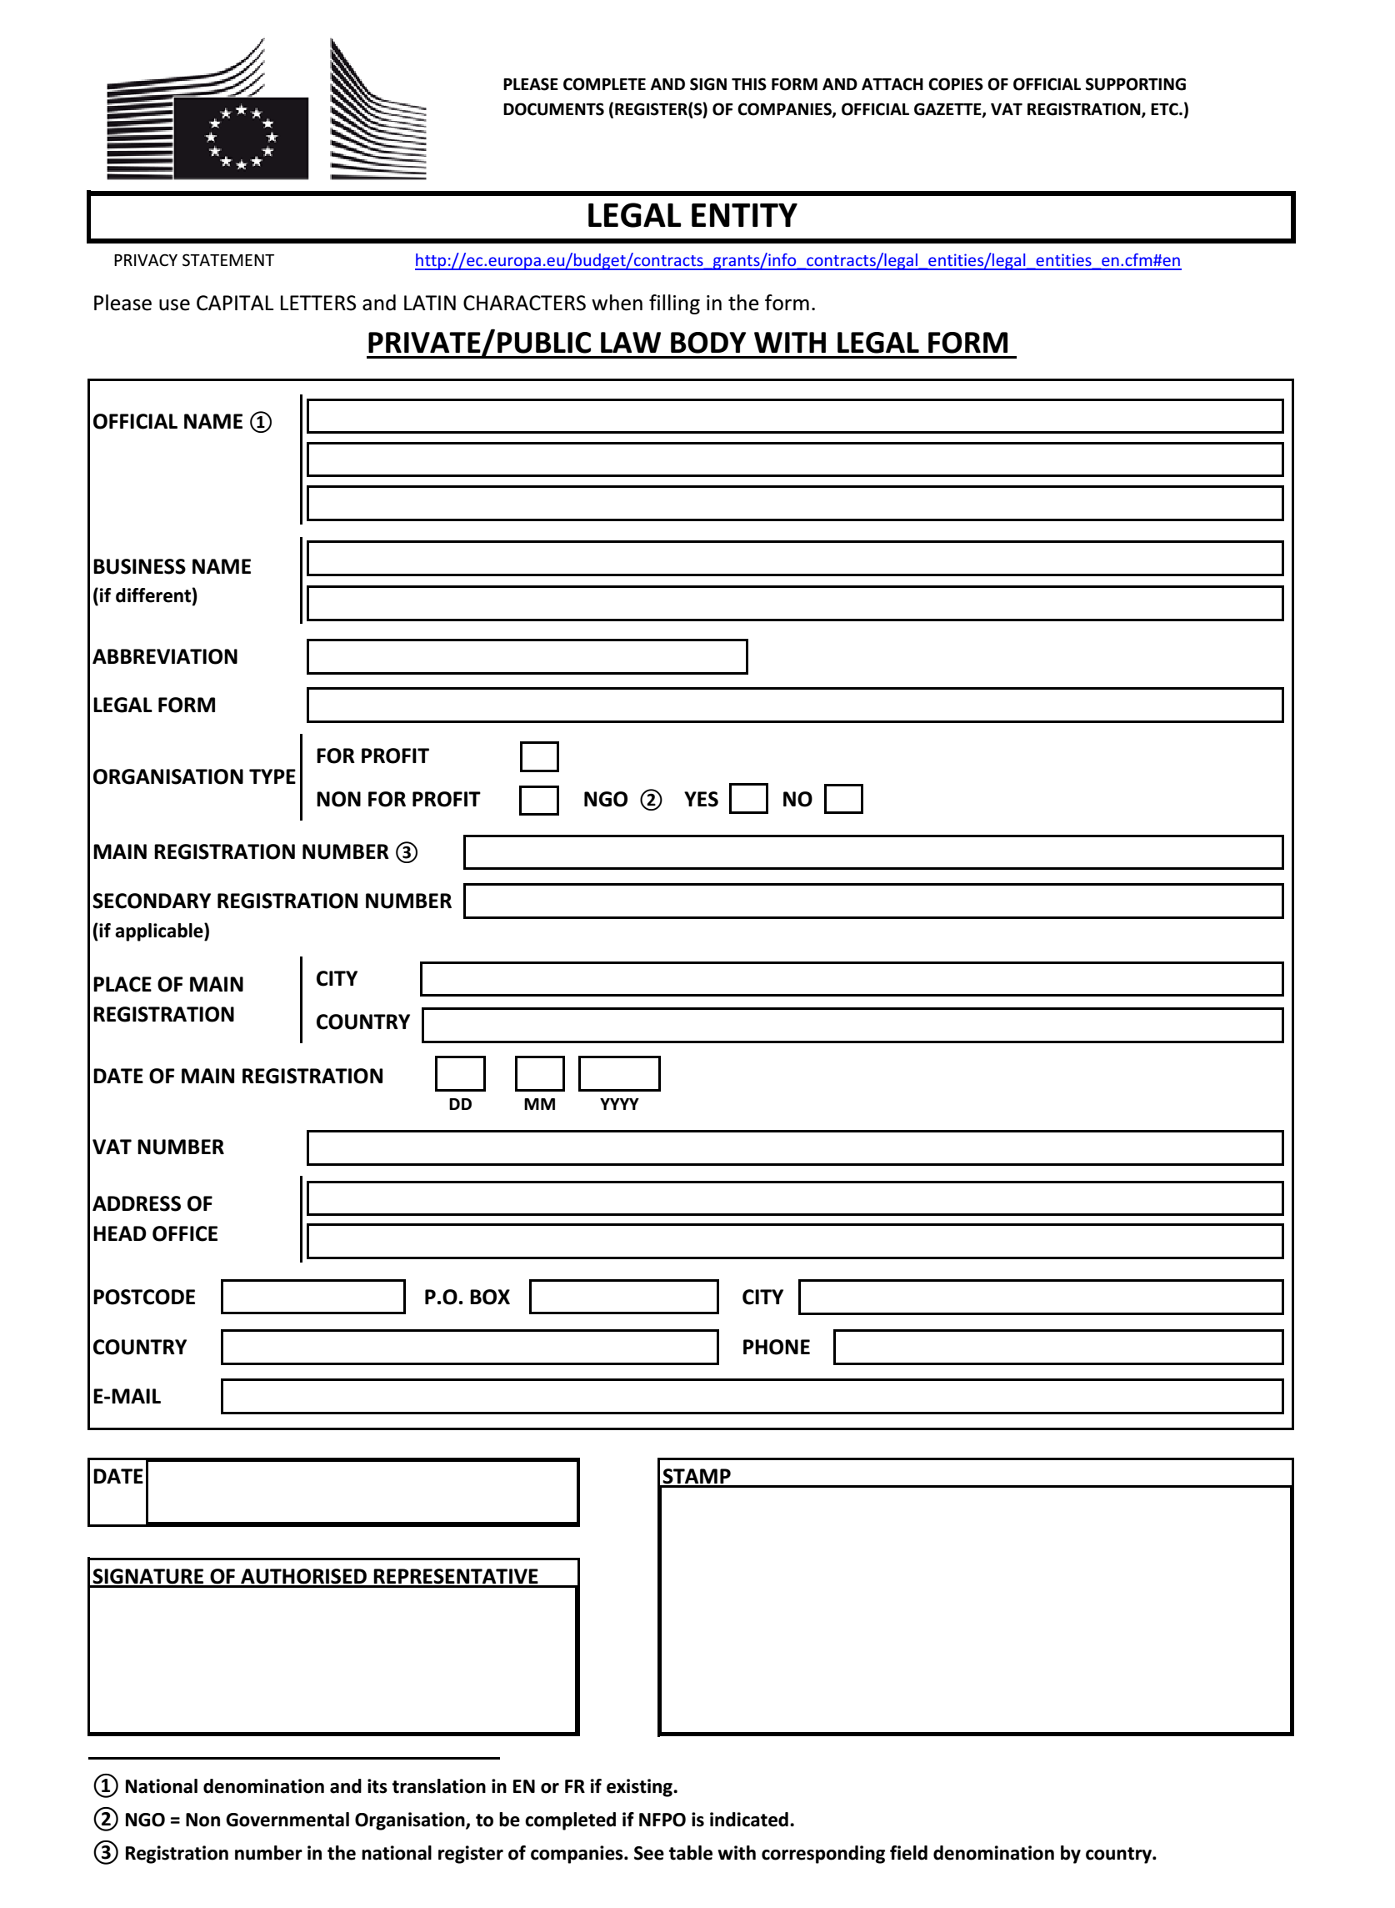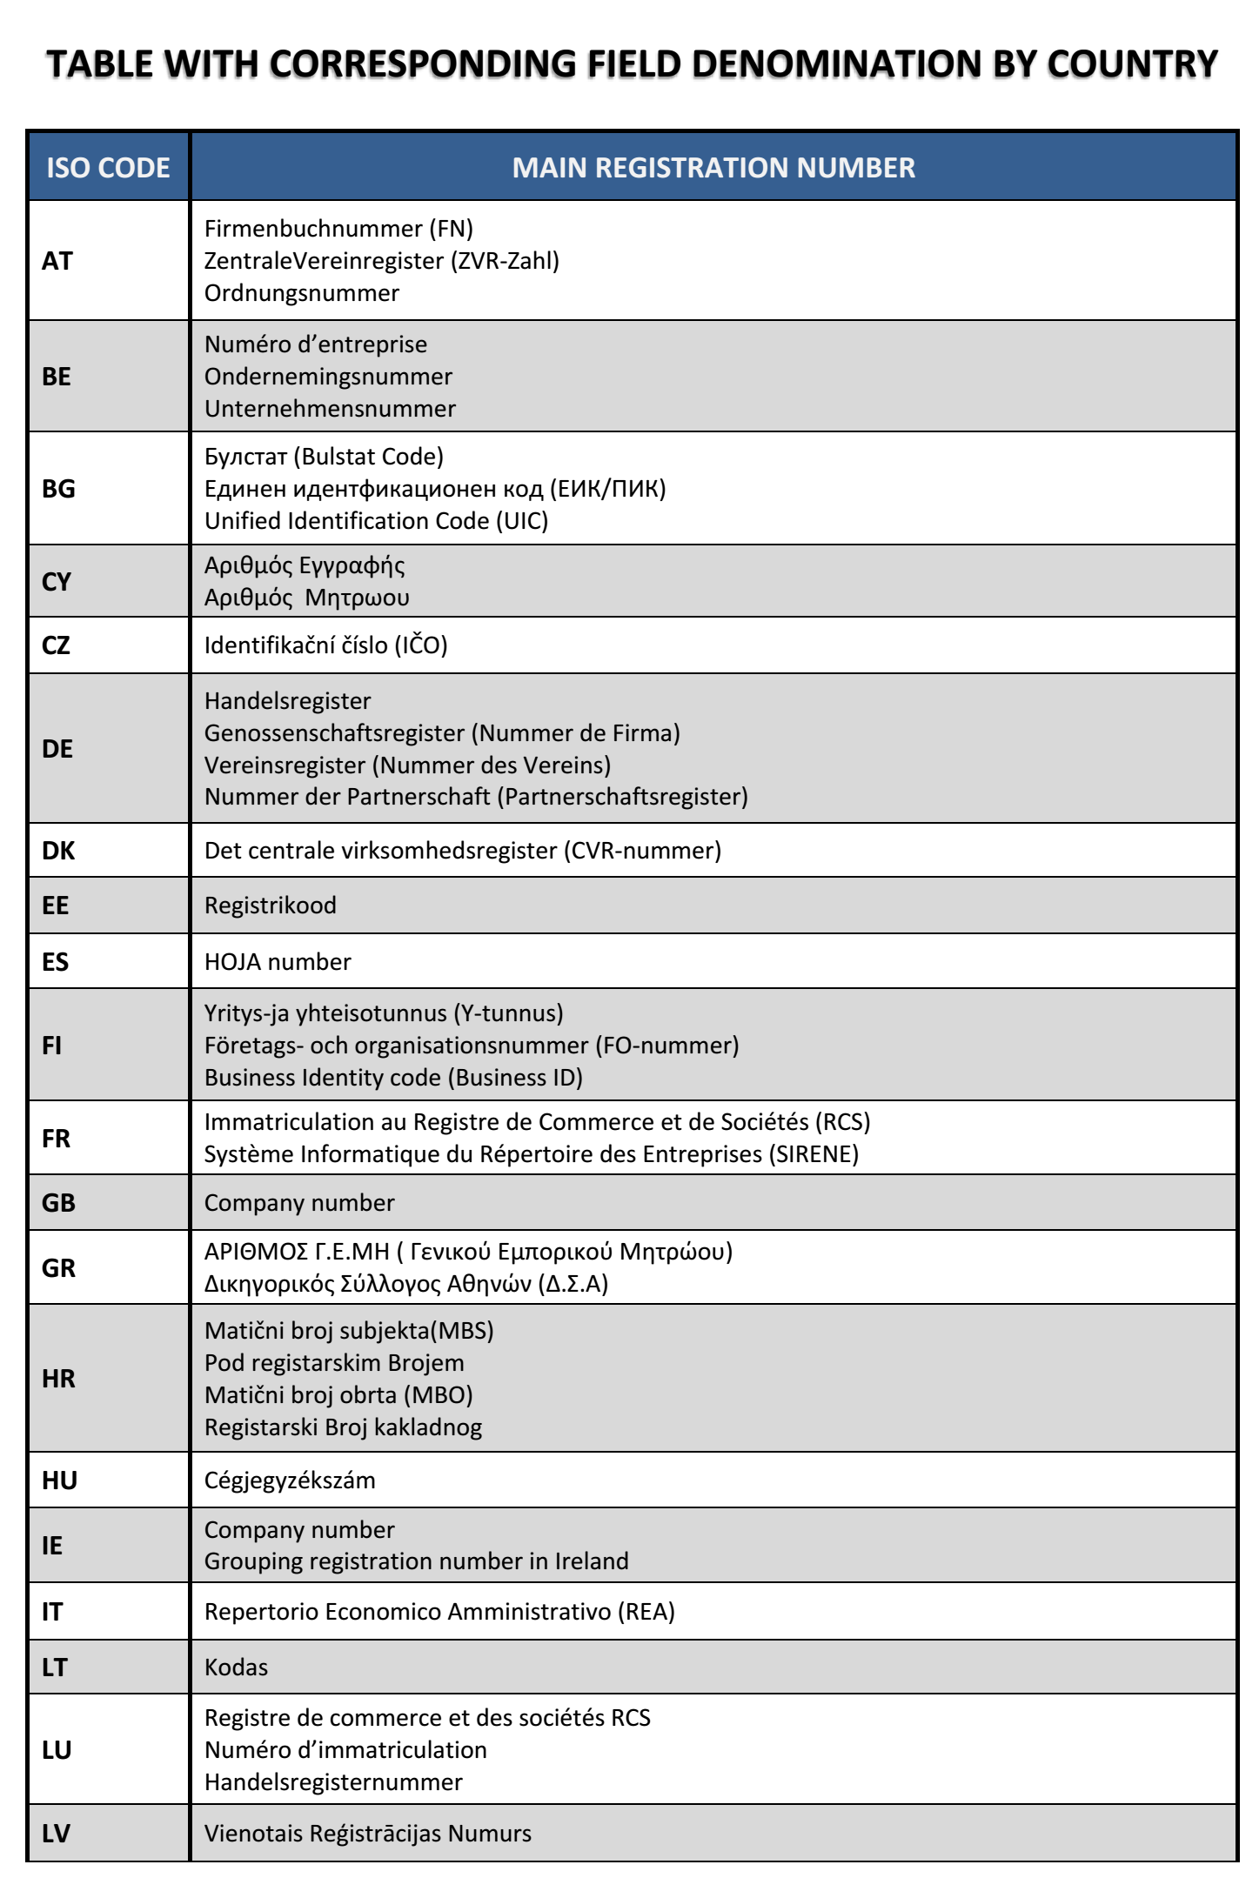

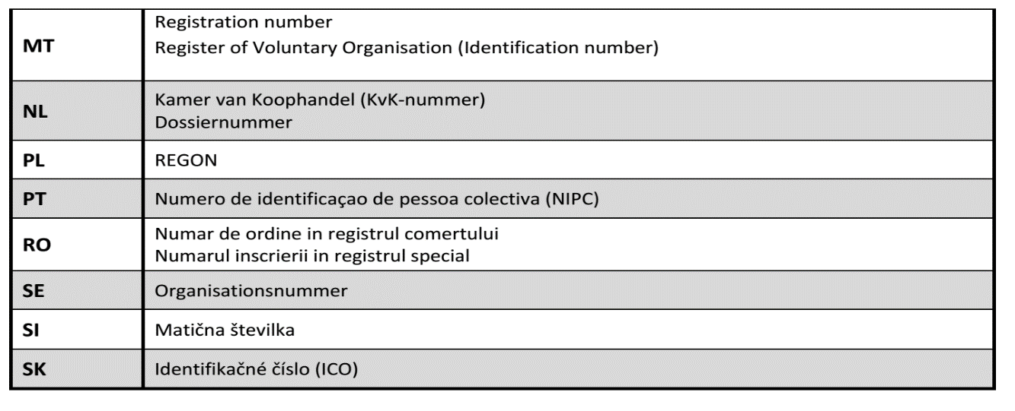

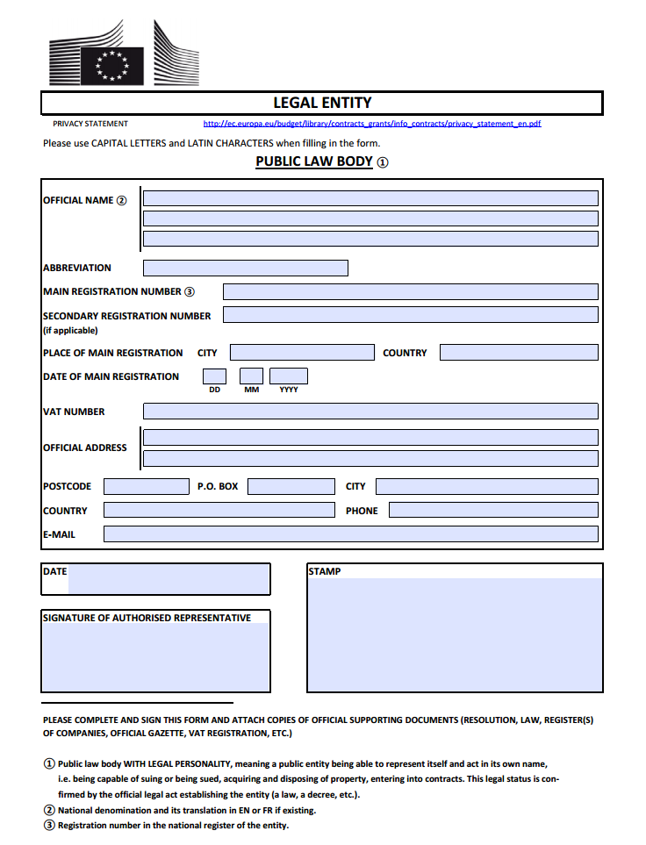

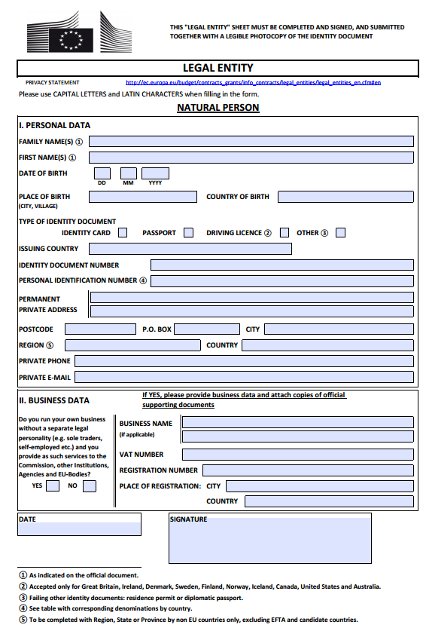

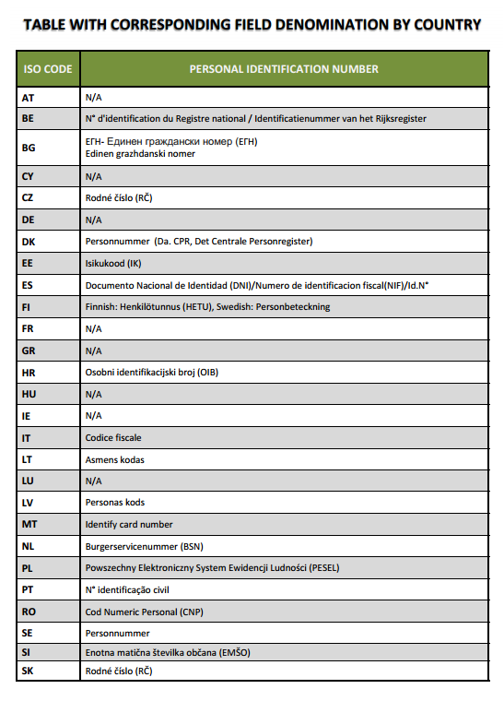

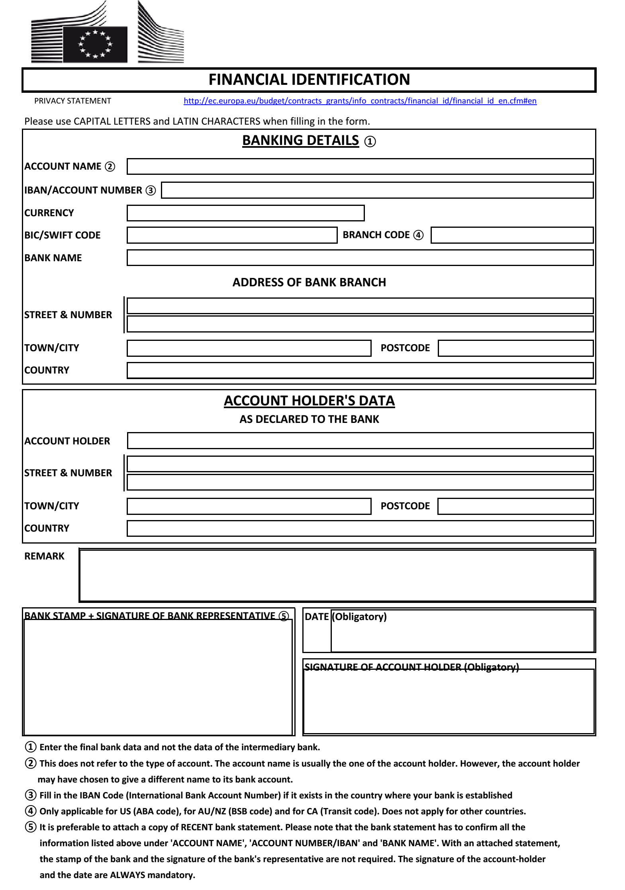



|  |
| --- |
| **TENDER DOSSIER** |
| **EUROPEAID/139244/DH/SUP/GE** |

|  |
| --- |
| **PART C** |

|  |
| --- |
| **ADMINISTRATIVE**  **COMPLIANCE GRID** |

|  |
| --- |
| **EVALUATION GRID** |

|  |
| --- |
| **PROVISIONAL/FINAL ACCEPTANCE CERTIFICATE** |

**ADMINISTRATIVE COMPLIANCE GRID**

[To be completed by the Evaluation Committee]

|  |  |  |  |
| --- | --- | --- | --- |
| **Contract title :** | Supply, delivery, installation and commissioning of generators and stabilizers at various premises operated by the EUMM Georgia | **Publication reference :** | EUROPEAID/139244/DH/SUP/GE |

| Tender envelope number | Name of Tenderer | Is tenderer (consortium) nationality[12] eligible?  (Y/N) | Is documentation complete?  (Y/N) | Is language as required?  (Y/N) | Is tender submission form complete?  (Y/N) | Is tenderer's declaration signed (by all consortium members if a consortium)? (Yes/No/ Not Applicable) | Other administrative requirements of the tender dossier?  (Yes/No/Not applicable) | Overall decision?  (Accept / Reject) |
| --- | --- | --- | --- | --- | --- | --- | --- | --- |
| 1 |  |  |  |  |  |  |  |  |
| 2 |  |  |  |  |  |  |  |  |
| 3 |  |  |  |  |  |  |  |  |
| 4 |  |  |  |  |  |  |  |  |
| 5 |  |  |  |  |  |  |  |  |
| 6 |  |  |  |  |  |  |  |  |
| 7 |  |  |  |  |  |  |  |  |

|  |  |
| --- | --- |
| **Chairperson's name** |  |
| **Chairperson's signature** |  |
| **Date** |  |

# EVALUATION GRID

[To be completed by the Evaluation Committee]

|  |  |  |  |
| --- | --- | --- | --- |
| **Contract title :** | Supply, delivery, installation and commissioning of generators and stabilizers at various premises operated by the EUMM Georgia | **Publication reference :** | EUROPEAID/139244/DH/SUP/GE |

| Tender envelope No | Name of Tenderer | Rules of origin respected?  (Y/N) | Economic & financial capacity? (OK/a/b/…) | Professional capacity? (OK/a/b/…) | Technical capacity? (OK/a/b/…) | Compliance with [13]technical specifications? (OK/a/b/…) | Ancillary services as required? (OK/a/b/…/NA) | Subcontracting statement in accordance with art 6 of the General Conditions?  (Y/N) | Other technical requirements in tender dossier?  (Yes/No/Not applicable) | Technically compliant? Y/N) | Justification/ notes: |
| --- | --- | --- | --- | --- | --- | --- | --- | --- | --- | --- | --- |
| 1 |  |  |  |  |  |  |  |  |  |  |  |
| 2 |  |  |  |  |  |  |  |  |  |  |  |
| 3 |  |  |  |  |  |  |  |  |  |  |  |
| 4 |  |  |  |  |  |  |  |  |  |  |  |

|  |  |
| --- | --- |
| **Evaluator's name & signature** |  |
| **Evaluator's name & signature** |  |
| **Evaluator's name & signature** |  |
| **Date** |  |

**[PROVISIONAL / FINAL] ACCEPTANCE CERTIFICATE**

**Publication reference: EUROPEAID/139244/DH/SUP/GE**

**Title: Supply, delivery, installation and commissioning of generators and stabilizers at various premises operated by the EUMM Georgia**

|  |  |  |  |  |  |  |  |  |  |  |  |  |
| --- | --- | --- | --- | --- | --- | --- | --- | --- | --- | --- | --- | --- |
| **INDICATE TYPE OF ACCEPTANCE** | | |  |  |  |  |  |  |  |  | | |
|  |  |  |  |  |  |  |  |  |  |  | | |
| **Contract/PO No:** | |  | **Title:** |  | | | | | |  | | |
|  |  |  |  |  |  |  |  |  |  |  | | |
| **PI number:** | |  |  |  |  |  |  |  |  |  | | |
|  |  |  |  |  |  |  |  |  |  |  | | |
| **Contractor:** | |  |  |  | **Contracting Authority:** | | | |  | | | |
|  |  |  |  |  |  |  |  |  |  | | | |
|  |  |  |  |  |  |  |  |  |  | | | |
| **Item** | **Qty** | **Description** |  |  | **(Installation)** | **(Spare Parts)** | **(Consumables)** | **(Manuals)** | **(Training)** | **(Warranty)** | **Remarks** |
| **Delivery** | **Total Price** |
| 1 | […**]** | [……………………**]** |  |  |  |  |  |  |  |  |  |
| 2 | […**]** | [……………………**]** |  |  |  |  |  |  |  |  |  |
| 3 | […**]** | [……………………**]** |  |  |  |  |  |  |  |  |  |
| 4 | […**]** | [……………………**]** |  |  |  |  |  |  |  |  |  |
|  |  |  |  |  |  |  |  |  |  |  |  |
|  |  |  |  |  |  |  |  |  |  |  |  |
|  |  |  |  |  |  |  |  |  |  |  |  |
|  |  |  |  |  |  |  |  |  |  |  | |
|  |  |  |  | **0** | **0** |  |  |  |  |  | |
|  |  |  |  |  |  |  |  |  |  |  | | |
| [Provisional: All of the above mentioned items have been delivered, installed, tested and found compliant with the Technical Specifications of the supply contract.] | | | | | | | | | | | | |
| [Final: The Supplier has remedied any defect or damage occurred during the warranty period, as specified in the contract.] | | | | | | | | | | | | |
|  |  |  |  |  |  |  |  |  |  |  | | |
|  |  |  |  |  |  |  |  |  |  |  | | |
| **The Contracting Authority** | | | | | | | | | | | | |
| 1. The Project Manager (on behalf of the Contracting Authority)   Name  Signature   Date when inspected and validated Stamp  OR  Date of delivery in case items were  not delivered to the MHQ warehouse | | | | | | | | | | | | |
| **Goods delivery date to EUMM** (actual delivery date of goods should be indicated rather than C-11 issue date): | | | | | | | | | | | | |
| 2. For EUMM Warehouse (as applicable)  Name  Signature   Date when delivered to EUMM Stamp | | | | | | | | | | | | |
| 3. The EUMM Assets Management Section (as applicable)  Name  Signature   Date when barcoded and/or recorded Stamp | | | | | | | | | | | | |
| **The Contractor** | | | | | | | | | | | | |
| 0. The Project Manager (on behalf of the Contractor)   Name  Signature   Date Stamp | | | | | | | | | | | | |



|  |
| --- |
| **TENDER DOSSIER** |
| **EUROPEAID/139244/DH/SUP/GE** |

|  |
| --- |
| **PART D** |

|  |
| --- |
| **TENDER FORM FOR A**  **SUPPLY CONTRACT** |

# TENDER FORM FOR A SUPPLY CONTRACT

Publication reference: EUROPEAID/139244/DH/SUP/GE

Title of contract: Supply, delivery, installation and commissioning of generators and stabilizers at various premises operated by the EUMM Georgia.

**<Place and date>**

**A: The European Union Monitoring Mission in Georgia (EUMM)**

**One signed** form must be supplied together with the number of copies specified in the Instruction to Tenderers**.** The form must include a signed declaration using the annexed format from each legal entity making the application. Any additional documentation (brochure, letter, etc.) sent with the form will not be taken into consideration.Applications being submitted by a consortium (i.e. either a permanent, legally-established grouping or a grouping which has been constituted informally for a specific tender procedure) must follow the instructions applicable to the consortium leader and its members. The attachments to this submission form (i.e. declarations, statements, proofs) may be in original or copy. If copies are submitted, the originals must be dispatched to the Contracting Authority upon request. For economical and ecological reasons, we strongly recommend that you submit your files on paper-based materials (no plastic folder or divider). We also suggest you use double-sided print-outs as much as possible.

An economic operator may, where appropriate and for a particular contract, rely on the capacities of other entities, regardless of the legal nature of the links which it has with them. It must in that case prove to the contracting authority that it will have at its disposal the resources necessary for performance of the contract, for example by producing a commitment on the part of those entities to place those resources at its disposal. Such entities, for instance the parent company of the economic operator, must respect the same rules of eligibility and notably that of nationality, as the economic operator, as well as the relevant selection criteria. With regard to technical and professional criteria, an economic operator may only rely on the capacities of other entities where the latter will supply the supplies or perform the works or services for which these capacities are required. With regard to economic and financial criteria, the entities upon whose capacity the tenderer relies, become jointly and severally liable for the performance of the contract.

**1 SUBMITTED BY**

|  |  |  |
| --- | --- | --- |
|  | **Name(s) of tenderer(s)** | **Nationality[14]** |
| **Leader[15]** |  |  |

**2 CONTACT PERSON (for this tender)**

|  |  |
| --- | --- |
| **Name** |  |
| **Address** |  |
| **Telephone** |  |
| **Fax** |  |
| **E-mail** |  |

**3 ECONOMIC AND FINANCIAL CAPACITY[16]**

Please complete the following table of financial data[17] based on your annual accounts and your latest projections. If annual accounts are not yet available for the current year or past year, please provide your latest estimates in the columns marked with **. Figures in all columns must be calculated on the same basis to allow a direct, year-on-year comparison to be made (or, if the basis has changed, an explanation of the change must be provided as a footnote to the table). Any clarification or explanation which is judged necessary may also be provided.

|  |  |  |  |  |  |  |
| --- | --- | --- | --- | --- | --- | --- |
| **Financial data** | **2 years before last year[18]**  **(EUR)** | **Year before last year (EUR)** | **Last year (EUR)** | **Average[19] (EUR)** | **Past year**  **(Estimate) [Only if annual accounts are not yet available]**  **(EUR)\*\*** | **Current year (Estimate) (EUR)\*\*** |
| Annual turnover[20] , excluding this contract |  |  |  |  |  |  |
| Current Assets[21] |  |  |  |  |  |  |
| Current Liabilities[22] |  |  |  |  |  |  |

**4 STAFF RESOURCES**

Please provide the following personnel statistics for the current year and the two previous years.[23]

|  |  |  |  |  |  |  |  |  |
| --- | --- | --- | --- | --- | --- | --- | --- | --- |
| **Annual manpower** | **Year before past year** | | **Past year** | | **Current year** | | **Period average** | |
|  | **Overall** | **Relevant fields[24]** | **Overall** | **Relevant fields 22** | **Overall** | **Relevant fields22** | **Overall** | **Relevant fields22** |
| Permanent staff [25] |  |  |  |  |  |  |  |  |
| Other staff [26] |  |  |  |  |  |  |  |  |
| Total |  |  |  |  |  |  |  |  |
| Permanent staff as a proportion of total staff (%) | % | % | % | % | % | % | % | % |

**5 FIELDS OF SPECIALISATION**

Please use the table below to indicate the **specialisms relevant to this contract** of each legal entity making this tender, by using the names of these specialisms as the row headings and the name of the legal entity as the column headings. Show the relevant specialism(s) of each legal entity by placing a tick (✓) in the box corresponding to those specialisms in which the legal entity has significant experience. [**Maximum 10 specialisms**]

|  |  |  |  |  |
| --- | --- | --- | --- | --- |
|  | Leader | Member 2 | Member 3 | Etc … |
| Relevant specialism 1 |  |  |  |  |
| Relevant specialism 2 |  |  |  |  |
| Etc …[27] |  |  |  |  |

**6 EXPERIENCE**

Please complete a table using the format below to summarise the **major** **relevant supplies** carried out over the past 5 years[28] by the legal entity or entities making this tender. The number of references to be provided must not exceed **15** for the entire tender

|  |  |  |  |  |  |  |  |  |
| --- | --- | --- | --- | --- | --- | --- | --- | --- |
| **Ref #** (maximum 15) | **Project title** | | … | | | | | |
| **Name of legal entity** | **Country** | **Overall supply value (EUR)[29]** | **Proportion supplied by legal entity (%)** | **No of staff provided** | **Name of client** | **Origin of funding** | **Dates** | **Name of members if any** |
| … | … | … | … | … | … | … | … | … |
| **Detailed description of supply** | | | | | | **Related services provided** | | |
| … | | | | | | … | | |
|  | | | | | |  | | |

**7 TENDERER’S DECLARATION(S)**

**As part of their tender, each legal entity identified under point 1 of this form, including every consortium member, as well as each capacity-providing entity and each subcontractor providing more than 10% of the supplies, must submit a signed declaration using this format, together with the Declaration of honour on exclusion and selection criteria (Annex 1). The declaration may be in original or in copy. If copies are submitted the originals must be dispatched to the Contracting Authority upon request.**

In response to your letter of invitation to tender for the above contract,

we, the undersigned, hereby declare that:

**1** We have examined and accept in full the content of the dossier for invitation to tender No <……………………………….> of <date>. We hereby accept its provisions in their entirety, without reservation or restriction.

**2** We offer to deliver, in accordance with the terms of the tender dossier and the conditions and time limits laid down, without reserve or restriction:

**<**description of supplies with indication of quantities and origin**>**

**3** The price of our tender **excluding** spare parts and consumables, if applicable (excluding the discounts described under point 4) is:

<…………………..> Euro (EUR)

**4** We will grant a discount of <…>%, or <…………..> Euro (EUR) [in the event of our being awarded the contract].

**5** This tender is valid for a period of 90 days from the final date for submission of tenders.

**6** Our firm/company [and our subcontractors] has/have the following nationality:

**<**……………………………………………………………………**>**

**7** We are making this tender in our own right [as member in the consortium led by < name of the leader/ourselves>][30]. We confirm that we are not tendering for the same contract in any other form. We confirm, as a member in the consortium, that all members are jointly and severally liable by law for the execution of the contract, that the lead member is authorised to bind, and receive instructions for and on behalf of, each member, that the execution of the contract, including payments, is the responsibility of the lead member, and that all members in the joint venture/consortium are bound to remain in the joint venture/consortium for the entire period of the contract’s execution. We confirm, as capacity-providing entity to be jointly and severally bound in respect of the obligations under the contract, including for any recoverable amount.

**8** In the event that our tender is successful, we undertake, if required, to provide the proof usual under the law of the country in which we are effectively established that we do not fall into any of the exclusion situations. The date on the evidence or documents provided will be no earlier than 1 year before the date of submission of the tender and, in addition, we will provide a statement that our situation has not altered in the period which has elapsed since the evidence in question was drawn up.

We also undertake, if required, to provide evidence of financial and economic standing and technical and professional capacity according to the selection criteria for this call for tender specified in the contract notice, point 16. The documentary proofs required are listed in Section 2.4.11 of the Practical Guide.

We also understand that if we fail to provide the proof/evidence required, within 15 calendar days after receiving the notification of award, or if the information provided is proved false, the award may be considered null and void.

**9** We agree to abide by the ethics clauses in Clause 23 of the instructions to tenderers and, in particular, have no conflict of interests or any equivalent relation which may distort competition with other tenderers or other parties in the tender procedure at the time of the submission of this application.

**10** We will inform the Contracting Authority immediately if there is any change in the above circumstances at any stage during the implementation of the tasks. We also fully recognise and accept that any inaccurate or incomplete information deliberately provided in this application may result in our exclusion from this and other contracts funded by the EU/EDF.

**11** We note that the Contracting Authority is not bound to proceed with this invitation to tender and that it reserves the right to award only part of the contract. It will incur no liability towards us should it do so.

**12** We fully recognise and accept that if the above-mentioned persons participate in spite of being in any of the situations listed in Section 2.3.3.1 of the Practical Guide or if the declarations or information provided prove to be false, they may be subject to rejection from this procedure and to administrative sanctions in the form of exclusion and financial penalties representing 2 % to 10 % of the total estimated value of the contract being awarded and that this information may be published on the Commission website in accordance with the conditions set in Section 2.3.4 of the Practical Guide.

**13** We are aware that, for the purposes of safeguarding the EU's financial interests, our personal data may be transferred to internal audit services, to the Early Detection and Exclusion System, to the European Court of Auditors, to the Financial Irregularities Panel or to the European Anti-Fraud Office.

**If this declaration is being completed by a consortium member:**

The following table contains our financial data as included in the consortium’s tender form. These data are based on our annual audited accounts and our latest projections. Estimated figures (i.e. those not included in annual audited accounts) are given in italics. Figures in all columns have been provided on the same basis to allow a direct, year-on-year comparison to be made <except as explained in the footnote to the table>.

|  |  |  |  |  |  |  |
| --- | --- | --- | --- | --- | --- | --- |
| **Financial data** | **2 years before last year[31]**  **(EUR)** | **Year before last year (EUR)** | **Last year (EUR)** | **Average[32]  (EUR)** | **Past year (Estimate) [Only if annual accounts are not yet available]**  **(EUR)** | **Current year (Estimate)**  **(EUR)** |
| Annual turnover[33], excluding this contract |  |  |  |  |  |  |
| Current Assets[34] |  |  |  |  |  |  |
| Current Liabilities[35] |  |  |  |  |  |  |
| Current ratio (current assets/current liabilities) |  |  |  |  |  |  |

The following table contains our personnel statistics as included in the consortium’s tender form:

|  |  |  |  |  |  |  |  |  |
| --- | --- | --- | --- | --- | --- | --- | --- | --- |
| **Annual manpower** | **Year before past year** | | **Past year** | | **Current year** | | **Period average** | |
|  | **Overall** | **Relevant fields[36]** | **Overall** | **Relevant fields34** | **Overall** | **Relevant fields** 34 | **Overall** | **Relevant fields** 34 |
| Permanent staff [37] |  |  |  |  |  |  |  |  |
| Other staff [38] |  |  |  |  |  |  |  |  |
| Total |  |  |  |  |  |  |  |  |
| Permanent staff as a proportion of total staff (%) | % | % | % | % | % | % | % | % |

Yours faithfully

Name and first name: <…………………………………………………………………>

Duly authorised to sign this tender on behalf of:

**<**……………………………………………………………………………………**>**

Place and date: <…………………………………………………………….………….>

Stamp of the firm/company:

This tender includes the following annexes:

<Numbered list of annexes with titles>



|  |
| --- |
| **TENDER DOSSIER** |
| **EUROPEAID/139244/DH/SUP/GE** |

|  |
| --- |
| **ANNEX I** |

|  |
| --- |
| **DECLARATION OF HONOR ON EXCLUSION AND SELECTION CRITERIA** |

**Declaration on honour on  
exclusion criteria and selection criteria**

The undersigned [*insert name of the signatory of this form*], representing:

|  |  |
| --- | --- |
| (*only for natural persons*) himself or herself | (*only for legal persons*) the following legal person: |
| ID or passport number:  (‘the person’) | Full official name:  Official legal form:  Statutory registration number**:**  Full official address:  VAT registration number:  (‘the person’) |

I – Situation of exclusion concerning the person

|  |  |  |
| --- | --- | --- |
| 1. declares that the above-mentioned person is in one of the following situations: | YES | NO |
| 1. it is bankrupt, subject to insolvency or winding up procedures, its assets are being administered by a liquidator or by a court, it is in an arrangement with creditors, its business activities are suspended or it is in any analogous situation arising from a similar procedure provided for under national legislation or regulations; |  |  |
| 1. it has been established by a final judgement or a final administrative decision that the person is in breach of its obligations relating to the payment of taxes or social security contributions in accordance with the law of the country in which it is established, with those of the country in which the contracting authority is located or those of the country of the performance of the contract; |  |  |
| 1. it has been established by a final judgement or a final administrative decision that the person is guilty of grave professional misconduct by having violated applicable laws or regulations or ethical standards of the profession to which the person belongs, or by having engaged in any wrongful conduct which has an impact on its professional credibity where such conduct denotes wrongful intent or gross negligence, including, in particular, any of the following: |  | |
| (i) fraudulently or negligently misrepresenting information required for the verification of the absence of grounds for exclusion or the fulfilment of selection criteria or in the performance of a contract; |  |  |
| (ii) entering into agreement with other persons with the aim of distorting competition; |  |  |
| (iii) violating intellectual property rights; |  |  |
| (iv) attempting to influence the decision-making process of the contracting authority during the award procedure; |  |  |
| (v) attempting to obtain confidential information that may confer upon it undue advantages in the award procedure***;*** |  |  |
| 1. it has been established by a final judgement that the person is guilty of the following: |  | |
| (i) fraud, within the meaning of Article 1 of the Convention on the protection of the European Communities' financial interests, drawn up by the Council Act of 26 July 1995; |  |  |
| (ii) corruption, as defined in Article 3 of the Convention on the fight against corruption involving officials of the European Communities or officials of EU Member States, drawn up by the Council Act of 26 May 1997, and in Article 2(1) of Council Framework Decision 2003/568/JHA, as well as corruption as defined in the legal provisions of the country where the contracting authority is located, the country in which the person is established or the country of the performance of the contract; |  |  |
| (iii) participation in a criminal organisation, as defined in Article 2 of Council Framework Decision 2008/841/JHA; |  |  |
| (iv) money laundering or terrorist financing, as defined in Article 1 of Directive 2005/60/EC of the European Parliament and of the Council; |  |  |
| (v) terrorist-related offences or offences linked to terrorist activities, as defined in Articles 1 and 3 of Council Framework Decision 2002/475/JHA, respectively, or inciting, aiding, abetting or attempting to commit such offences, as referred to in Article 4 of that Decision; |  |  |
| (vi) child labour or other forms of trafficking in human beings as defined in Article 2 of Directive 2011/36/EU of the European Parliament and of the Council; |  |  |
| 1. the person has shown significant deficiencies in complying with the main obligations in the performance of a contract financed by the Union’s budget, which has led to its early termination or to the application of liquidated damages or other contractual penalties, or which has been discovered following checks, audits or investigations by an Authorising Officer, OLAF or the Court of Auditors; |  |  |
| 1. it has been established by a final judgment or final administrative decision that the person has committed an irregularity within the meaning of Article 1(2) of Council Regulation (EC, Euratom) No 2988/95; |  |  |
| 1. for the situations of grave professional misconduct, fraud, corruption, other criminal offences, significant deficiencies in the performance of the contract or irregularity, the applicant is subject to: 2. facts established in the context of audits or investigations carried out by the Court of Auditors, OLAF or internal audit, or any other check, audit or control performed under the responsibility of an authorising officer of an EU institution, of a European office or of an EU agency or body; 3. non-final administrative decisions which may include disciplinary measures taken by the competent supervisory body responsible for the verification of the application of standards of professional ethics; 4. decisions of the ECB, the EIB, the European Investment Fund or international organisations; 5. decisions of the Commission relating to the infringement of the Union's competition rules or of a national competent authority relating to the infringement of Union or national competition law; or 6. decisions of exclusion by an authorising officer of an EU institution, of a European office or of an EU agency or body. |  |  |

II – Situations of exclusion concerning natural persons with power of representation, decision-making or control over the legal person

***Not applicable to natural persons, Member States and local authorities***

|  |  |  |  |
| --- | --- | --- | --- |
| 1. declares that a natural person who is a member of the administrative, management or supervisory body of the above-mentioned legal person, or who has powers of representation, decision or control with regard to the above-mentioned legal person (this covers company directors, members of management or supervisory bodies, and cases where one natural person holds a majority of shares) is in one of the following situations: | YES | NO | N/A |
| Situation (c) above (grave professional misconduct) |  |  |  |
| Situation (d) above (fraud, corruption or other criminal offence) |  |  |  |
| Situation (e) above (significant deficiencies in performance of a contract ) |  |  |  |
| Situation (f) above (irregularity) |  |  |  |

III – Situations of exclusion concerning natural or legal persons assuming unlimited liability for the debts of the legal person

|  |  |  |  |
| --- | --- | --- | --- |
| 1. declares that a natural or legal person that assumes unlimited liability for the debts of the above-mentioned legal person is in one of the following situations: | YES | NO | N/A |
| Situation (a) above (bankruptcy) |  |  |  |
| Situation (b) above (breach in payment of taxes or social security contributions) |  |  |  |

IV – Grounds for rejection from this procedure

|  |  |  |
| --- | --- | --- |
| 1. declares that the above-mentioned person: | YES | NO |
| 1. has distorted competition by being previously involved in the preparation of procurement documents for this procurement procedure. |  |  |

V – Remedial measures

If the person declares one of the situations of exclusion listed above, it must indicate measures it has taken to remedy the exclusion situation, thus demonstrating its reliability. This may include e.g. technical, organisational and personnel measures to prevent further occurrence, compensation of damage or payment of fines. The relevant documentary evidence which illustrates the remedial measures taken must be provided in annex to this declaration. This does not apply for situations referred in point (d) of this declaration.

VI – Evidence upon request

Upon request and within the time limit set by the contracting authority the person must provide information on the persons that are members of the administrative, management or supervisory body. It must also provide the following evidence concerning the person itself and concerning the natural or legal persons which assume unlimited liability for the debt of the person:

For situations described in (a), (c), (d) or (f), production of a recent extract from the judicial record is required or, failing that, an equivalent document recently issued by a judicial or administrative authority in the country of establishment of the person showing that those requirements are satisfied.

For the situation described in point (a) or (b), production of recent certificates issued by the competent authorities of the State concerned are required. These documents must provide evidence covering all taxes and social security contributions for which the person is liable, including for example, VAT, income tax (natural persons only), company tax (legal persons only) and social security contributions. Where any document described above is not issued in the country concerned, it may be replaced by a sworn statement made before a judicial authority or notary or, failing that, a solemn statement made before an administrative authority or a qualified professional body in its country of establishment.

The person is not required to submit the evidence if it has already been submitted for another procurement procedure. The documents must have been issued no more than one year before the date of their request by the contracting authority and must still be valid at that date.

The signatory declares that the person has already provided the documentary evidence for a previous procedure and confirms that there has been no change in its situation:

|  |  |
| --- | --- |
| **Document** | **Full reference to previous procedure** |
| *Insert as many lines as necessary.* |  |

VII – Selection criteria

|  |  |  |  |  |
| --- | --- | --- | --- | --- |
| 1. declares that the above-mentioned person complies with the selection criteria applicable to it individually as provided in the tender specifications: | YES | NO | | N/A |
| 1. It has the legal and regulatory capacity to pursue the professional activity needed for performing the contract as required in point 16 of the Contract Notice; |  |  | |  |
| 1. It fulfills the applicable economic and financial criteria indicated in point 16 of the Contract Notice; |  |  | |  |
| 1. It fulfills the applicable technical and professional criteria indicated in point 16 of the Contract Notice. |  |  | |  |
| 1. if the above-mentioned person is the **sole tenderer** or the **leader in case of joint tender**, declares that: | YES | NO | N/A | |
| 1. the tenderer, including all members of the group in case of joint tender and including subcontractors if applicable, complies with all the selection criteria for which a consolidated asseessment will be made as provided in the tender specifications. |  |  | |  |

VII – Evidence for selection

The signatory declares that the above-mentioned person is able to provide the necessary supporting documents listed in the relevant sections of the tender specifications and which are not available electronically upon request and without delay.

The person is not required to submit the evidence if it has already been submitted for another procurement procedure. The documents must have been issued no more than one year before the date of their request by the contracting authority and must still be valid at that date.

The signatory declares that the person has already provided the documentary evidence for a previous procedure and confirms that there has been no change in its situation:

|  |  |
| --- | --- |
| **Document** | **Full reference to previous procedure** |
| *Insert as many lines as necessary.* |  |

***The above-mentioned person may be subject to rejection from this procedure and to administrative sanctions (exclusion or financial penalty) if any of the declarations or information provided as a condition for participating in this procedure prove to be false.***

Full name Date Signature

1. For international companies payment will be made in EUR. For Georgian based companies the payments will be made in GEL. All amounts payable shall be converted from EURO into GEL using the exchange rate of the commercial bank serving EUMM, Georgia applicable on the date of the transaction
2. DDP (Delivered Duty Paid) — Incoterms 2010 International Chamber of Commerce <http://www.iccwbo.org/products-and-services/trade-facilitation/incoterms-2010/the-incoterms-rules/> .
3. also available on <http://ec.europa.eu/europeaid/prag/document.do>
4. Pursuant to Regulation (EC) No 45/2001 on the protection of individuals with regard to the processing of personal data by the Community institutions and bodies and on the free movement of such data.
5. This link will lead you to the new "EuropeAid privacy statement" published among the Practical Guide General Annexes.
6. For international companies payment will be made in EUR. For Georgian based companies the payments will be made in GEL. All amounts payable shall be converted from EURO into GEL using the exchange rate of the commercial bank serving EUMM, Georgia applicable on the date of the transaction.
7. DDP (Delivered Duty Paid) - Incoterms 2010 International Chamber of Commerce <http://www.iccwbo.org/products-and-services/trade-facilitation/incoterms-2010/>
8. See Provisional acceptance, Article 31
9. For Georgian based companies, any and all prices quoted in the financial offer or budget breakdown (Annex IV) – which must be expressed in Euro (EUR) will however be paid in Georgian Lari (GEL) – using the exchange rate of EUMM serving commercial bank applicable on the day of transaction.
10. DDP (Delivered Duty Paid) - Incoterms 2010 International Chamber of Commerce <http://www.iccwbo.org/products-and-services/trade-facilitation/incoterms-2010/>
11. DDP (Delivered Duty Paid) – Incoterms 2010 International Chamber of Commerce <http://www.iccwbo.org/products-and-services/trade-facilitation/incoterms-2010/>
12. If the tender has been submitted by a consortium, the nationalities of **all** the consortium members must be eligible
13. The selection criteria, in the previous section of this form, have to be met before the technical requirements are assessed.
14. Country in which the legal entity is registered.
15. add/delete additional lines for members as appropriate. Note that a subcontractor is not considered to be a member for the purposes of this tender procedure. Subsequently, the data of the subcontractor must not appear in the data related to the economic, financial and professional capacity. If this tender is being submitted by an individual tenderer, the name of the tenderer should be entered as ‘**leader**’ (and all other lines should be deleted).
16. Natural persons have to prove their capacity in accordance with the selection criteria and by the appropriate means.
17. If this application is submitted by a consortium, the data in the table above must be the sum of the data in the corresponding tables in the declarations provided by the consortium members — see point 7 of this tender form. Consolidated data are not requested for financial ratios.
18. Last year=last accounting year for which the entity's accounts have been closed.
19. Amounts entered in the ‘Average’ column must be the mathematical average of the amounts entered in the three preceding columns of the same row.
20. The gross inflow of economic benefits (cash, receivables, other assets) arising from the ordinary operating activities of the enterprise (such as sales of goods, sales of services, interest, royalties, and dividends) during the year.
21. A balance sheet account that represents the value of all assets that are reasonably expected to be converted into cash within one year in the normal course of business. Current assets include cash, accounts receivable, inventory, marketable securities, prepaid expenses and other liquid assets that can be readily converted to cash.  
22. A company's debts or obligations that are due within one year. Current liabilities appear on the company's balance sheet and include short term debt, accounts payable, accrued liabilities and other debts.
23. If this tender is submitted by a consortium, the data in the table above must be the sum of the data in the corresponding tables in the declarations provided by the consortium members — see point 7 of this tender form. Consolidated data are not requested for financial ratios.
24. Corresponding to the relevant specialisms identified in point 5 below.
25. Staff directlyemployed by the Tenderer on a permanent basis (i.e. under indefinite contracts).
26. Other staff not directlyemployed by the Tenderer on a permanent basis (i.e. under fixed-term contracts).
27. add/delete additional lines and/or rows as appropriate. If this tender is being submitted by an individual legal entity, the name of the legal entity should be entered as ‘Leader’ (and all other columns should be deleted).
28. In the case of framework contracts (without contractual value), only specific contracts corresponding to assignments implemented under such framework contracts will be considered.
29. Amounts actually paid, without the effect of inflation.
30. Delete as applicable
31. Last year = last accounting year for which the entity's accounts have been closed.
32. Amounts entered in the ‘Average’ column must be the mathematical average of the amounts entered in the three preceding columns of the same row.
33. The gross inflow of economic benefits (cash, receivables, other assets) arising from the ordinary operating activities of the enterprise (such as sales of goods, sales of services, interest, royalties, and dividends) during the year.
34. A balance sheet account that represents the value of all assets that are reasonably expected to be converted into cash within one year in the normal course of business. Current assets include cash, accounts receivable, inventory, marketable securities, prepaid expenses and other liquid assets that can be readily converted to cash.  
35. A company's debts or obligations that are due within one year. Current liabilities appear on the company's balance sheet and include short term debt, accounts payable, accrued liabilities and other debts.
36. Corresponding to the relevant specialisms identified in point 5 above
37. Staff directlyemployed by the Tenderer on a permanent basis (i.e. under indefinite contracts)
38. Other staff not directlyemployed by the Tenderer on a permanent basis (i.e. under fixed-term contracts)